Supplemental Materials

Robert M Flight, Praneeth S Bhatt, and Hunter NB Moseley

2024-02-01 08:27:52.604683

## Limits of Detection Issues in Datasets

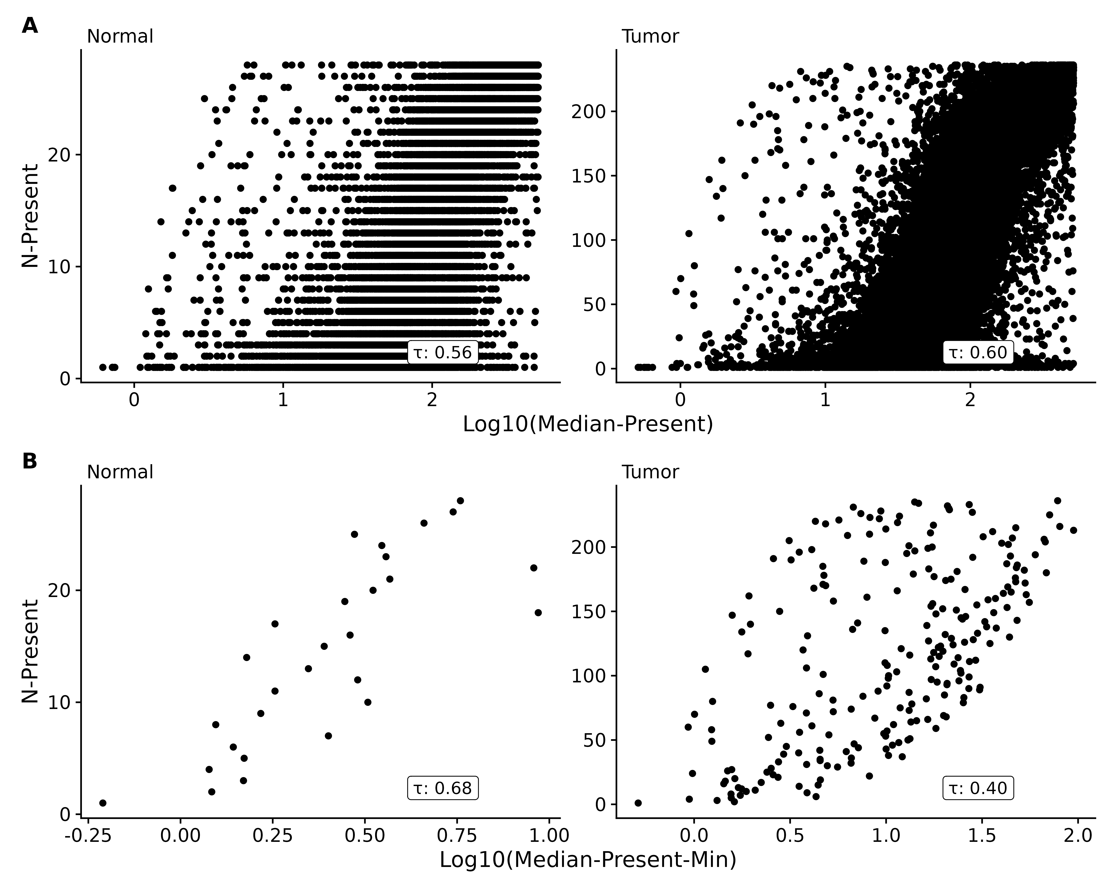

Figure S1. Adenocarcinoma dataset count medians by number of samples feature was present in. **A**: Log10 of medians for present values compared to the number of samples the feature was present in. **B**: Log10 of minimum median for each value of number of samples the feature was present in.

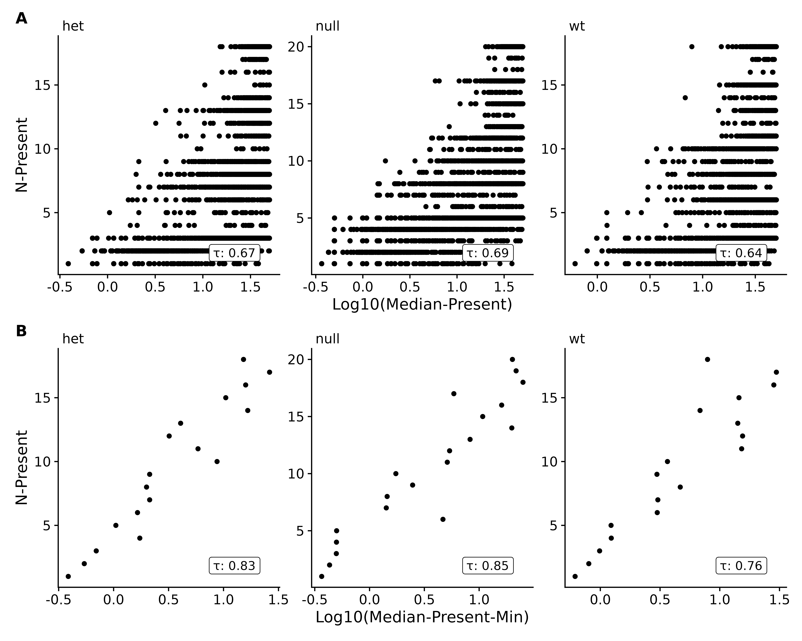

Figure S2. EGFR genotype dataset count medians by number of samples feature was present in. **A**: Log10 of medians for present values compared to the number of samples the feature was present in. **B**: Log10 of minimum median for each value of number of samples the feature was present in.

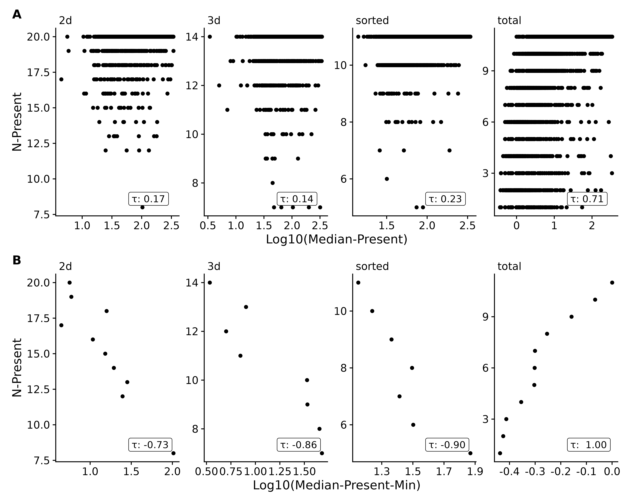

Figure S3. EGFR genotype and tumor culture dataset count medians by number of samples feature was present in. **A**: Log10 of medians for present values compared to the number of samples the feature was present in. **B**: Log10 of minimum median for each value of number of samples the feature was present in.



Figure S4. EGFR genotype and tumor culture dataset count medians by number of samples feature was present in. **A**: Log10 of medians for present values compared to the number of samples the feature was present in. **B**: Log10 of minimum median for each value of number of samples the feature was present in.

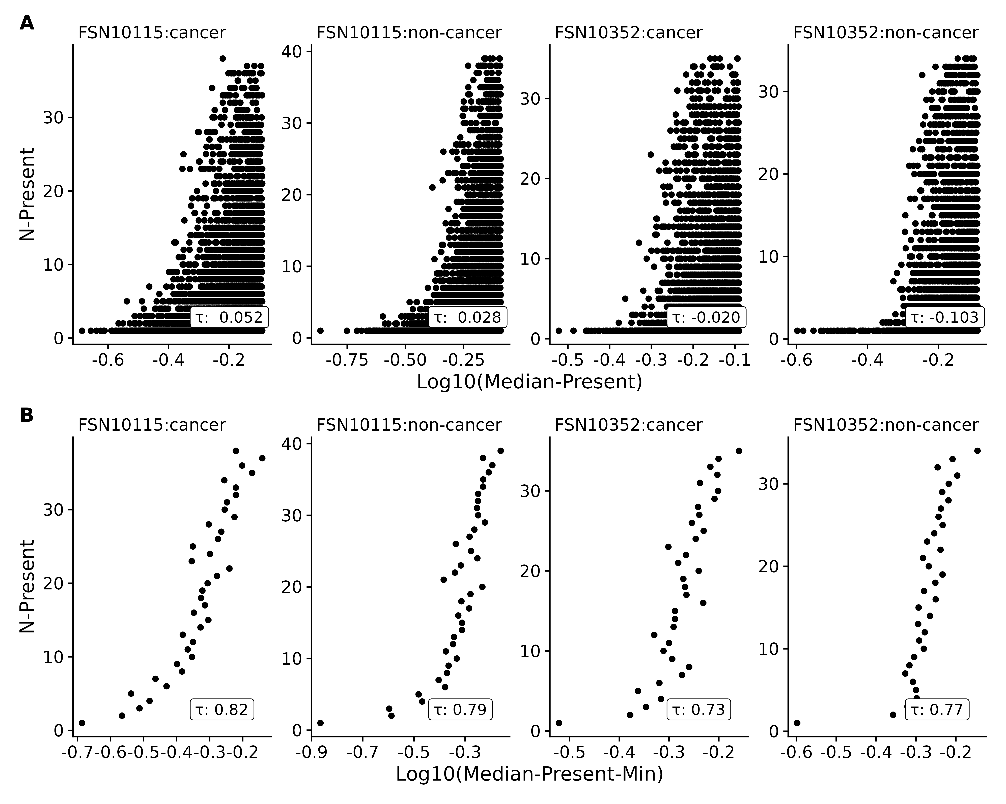

Figure S5. Non-small-cell-lung-cancer (NSCLC) lipidomics dataset count medians by number of samples feature was present in. **A**: Log10 of medians for present values compared to the number of samples the feature was present in. **B**: Log10 of minimum median for each value of number of samples the feature was present in.

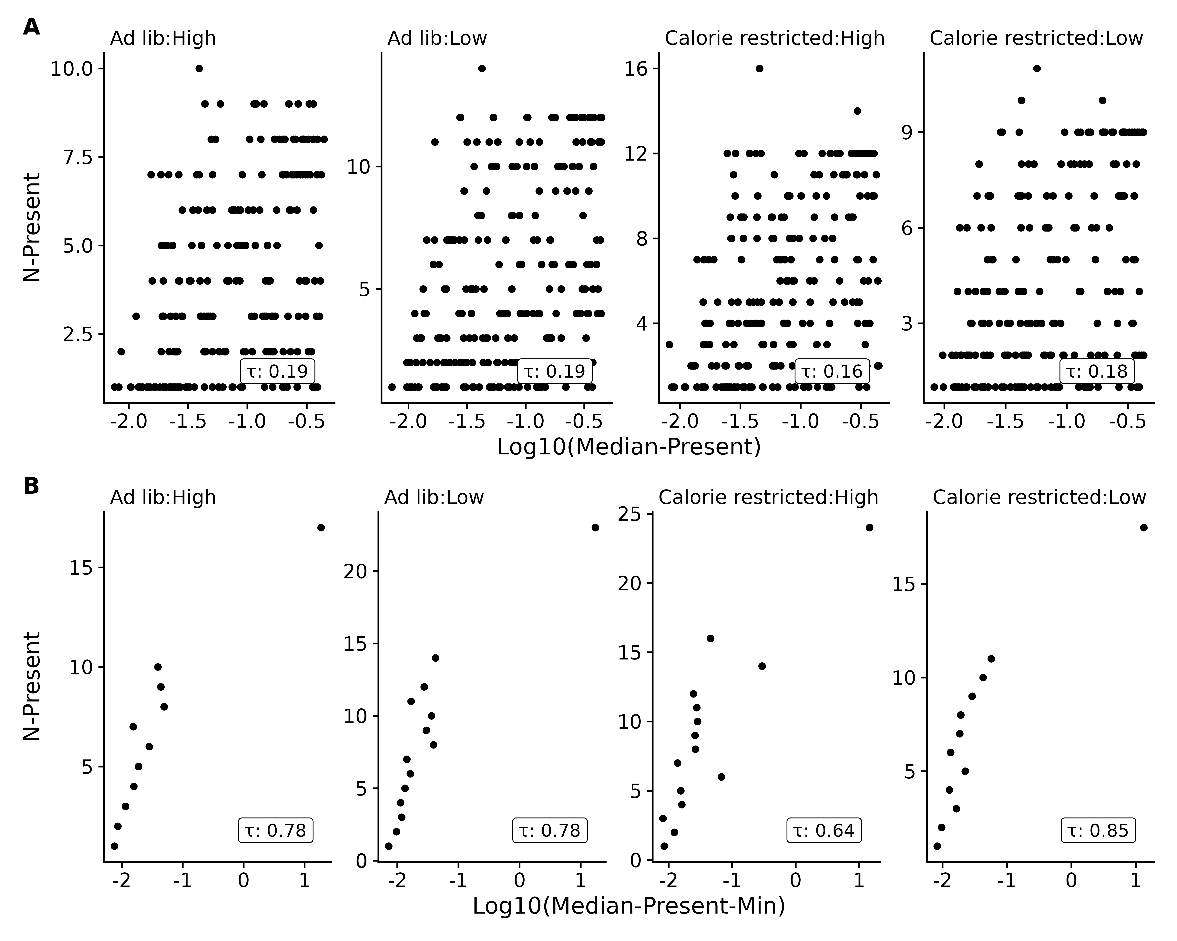

Figure S6. Rat stamina dataset count medians by number of samples feature was present in. **A**: Log10 of medians for present values compared to the number of samples the feature was present in. **B**: Log10 of minimum median for each value of number of samples the feature was present in.

## Simulated Data

### Simple Data Set

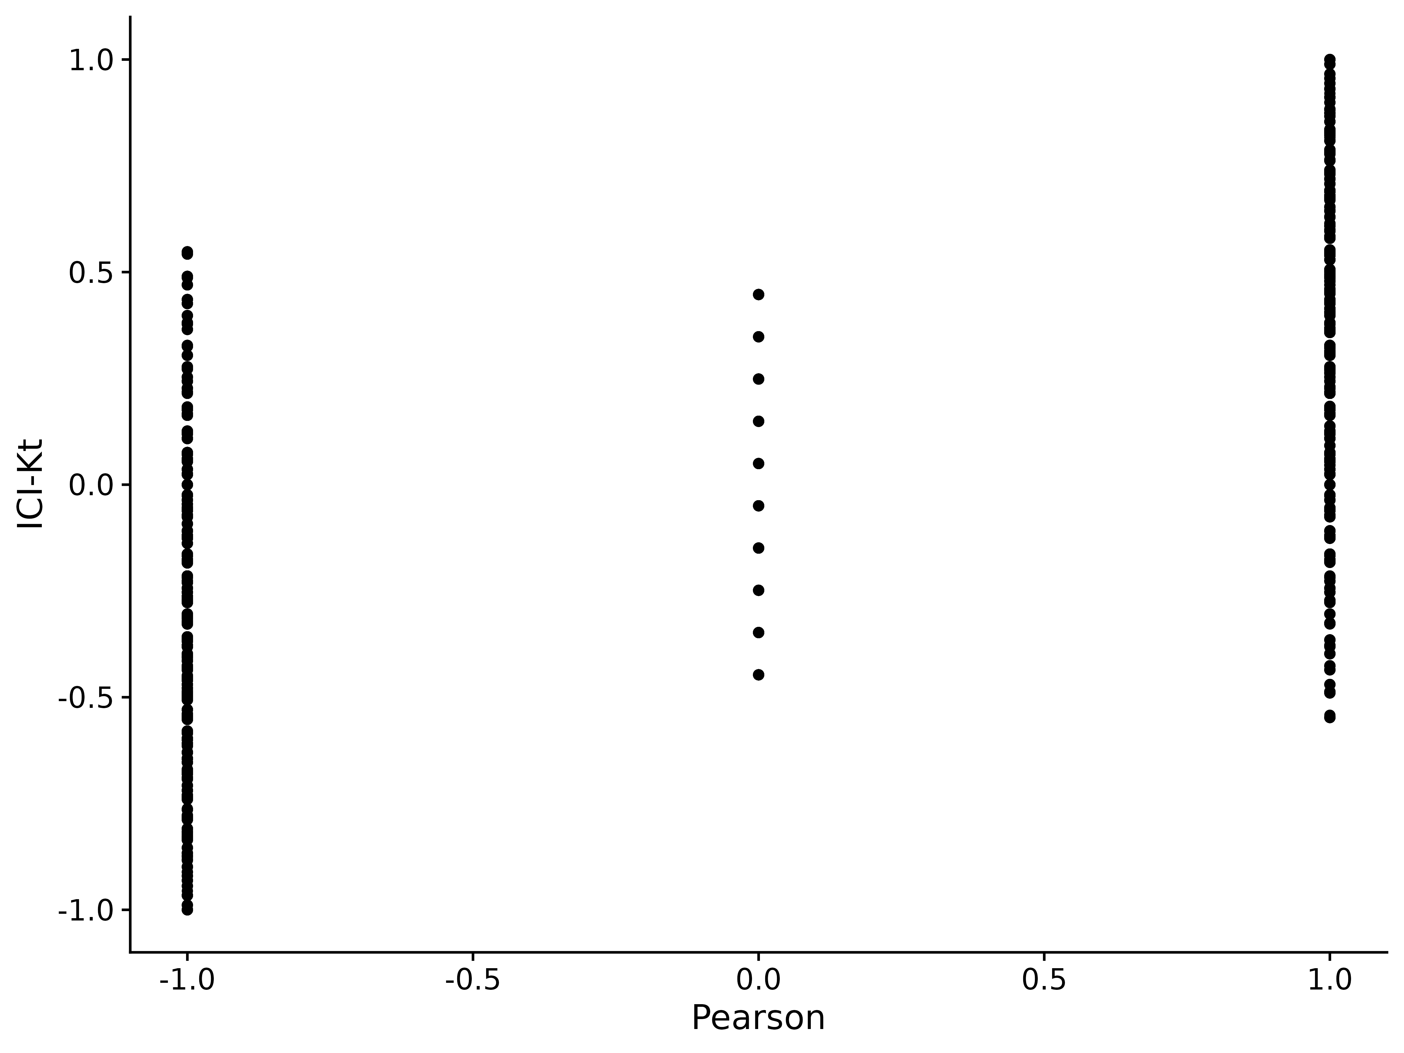

Figure S7. Comparison of ICI-Kt and Pearson correlations for perfectly positive and negatively correlated samples, systematically replacing values with NA. NA values from Pearson were replaced with zero for this comparison.

We can also examine the full set of positive and negative correlations generated as we vary the number of missing entries between two positively correlated samples and two negatively correlated samples. These distributions are shown in Figure S9. We can see that the distributions from both ICI-Kt and Kendall-tau are the same, which is expected given we replaced missing values (NA) with zero *within* the ICI-Kt code, and replaced missing values (NA) with zero prior to calculating Kendall-tau correlations.

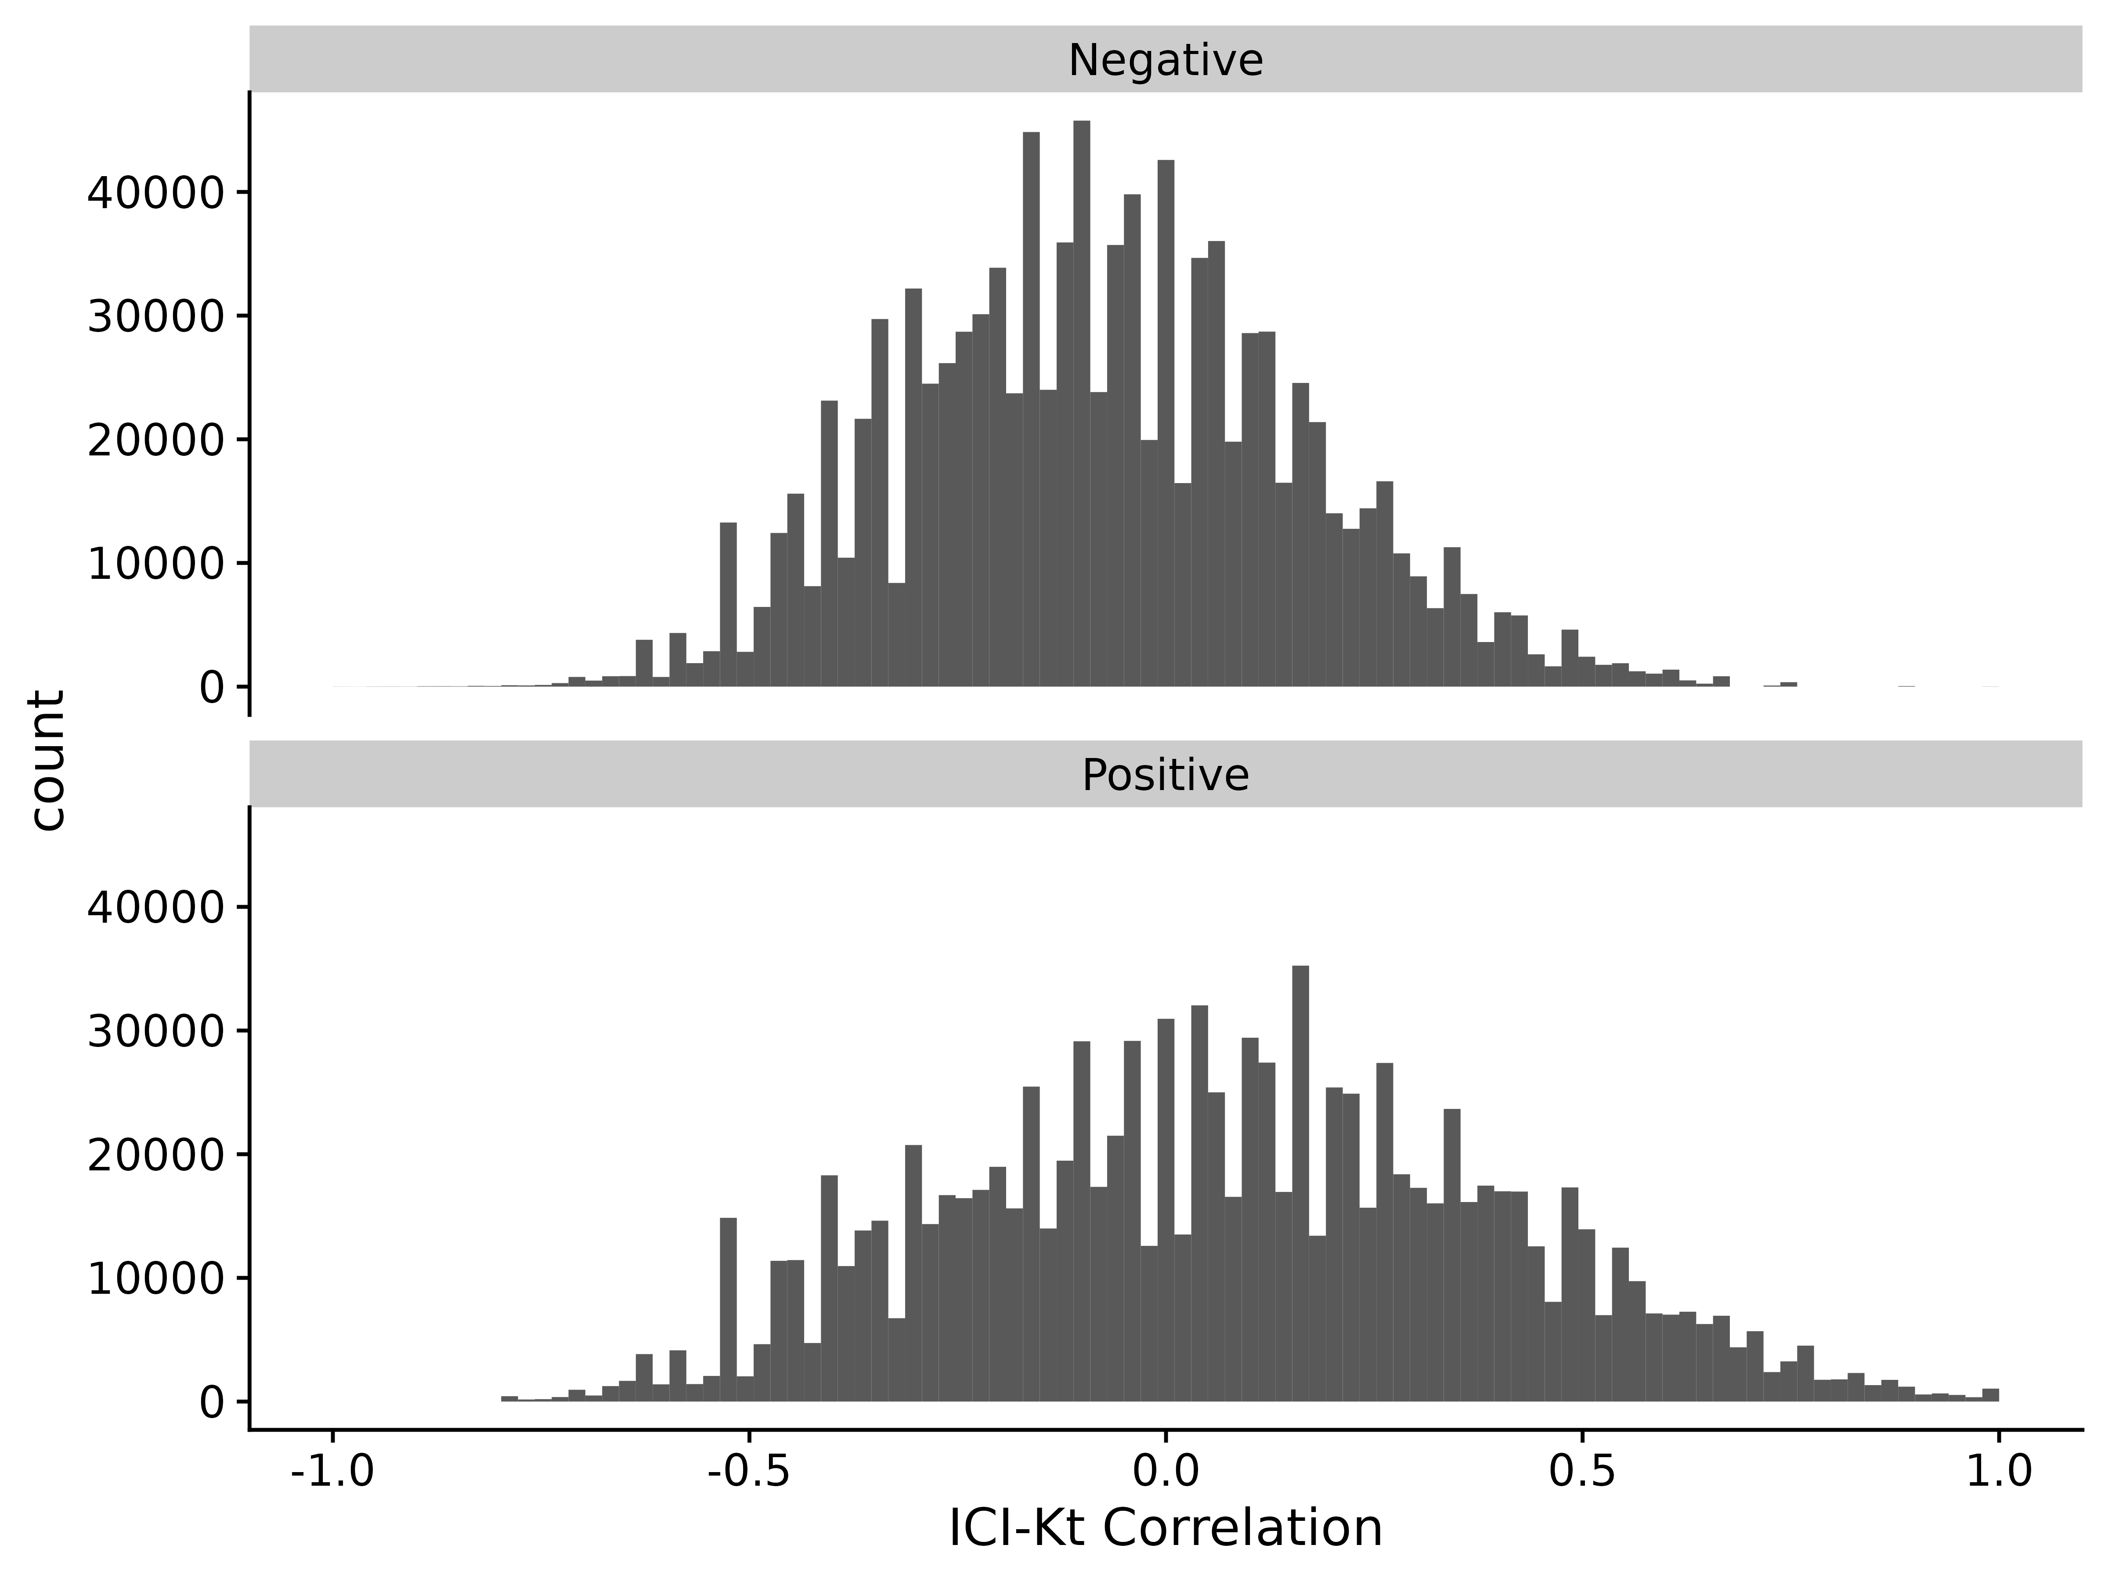

Figure S8. ICI-Kendall-tau correlation as missing values are varied between two samples.

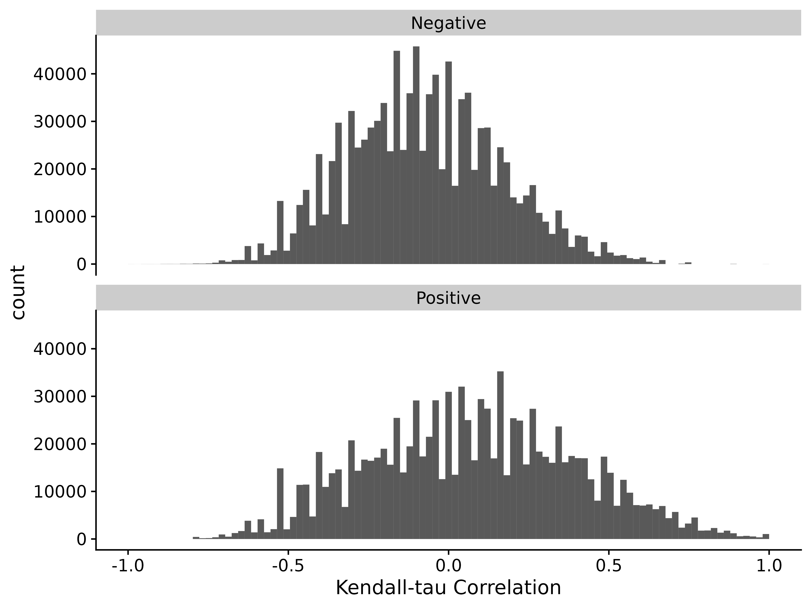

Figure S9. Kendall-tau correlation as missing values are varied between two samples and replaced with 0 before calculating Kendall-tau.

### Semi-Realistic Data Set

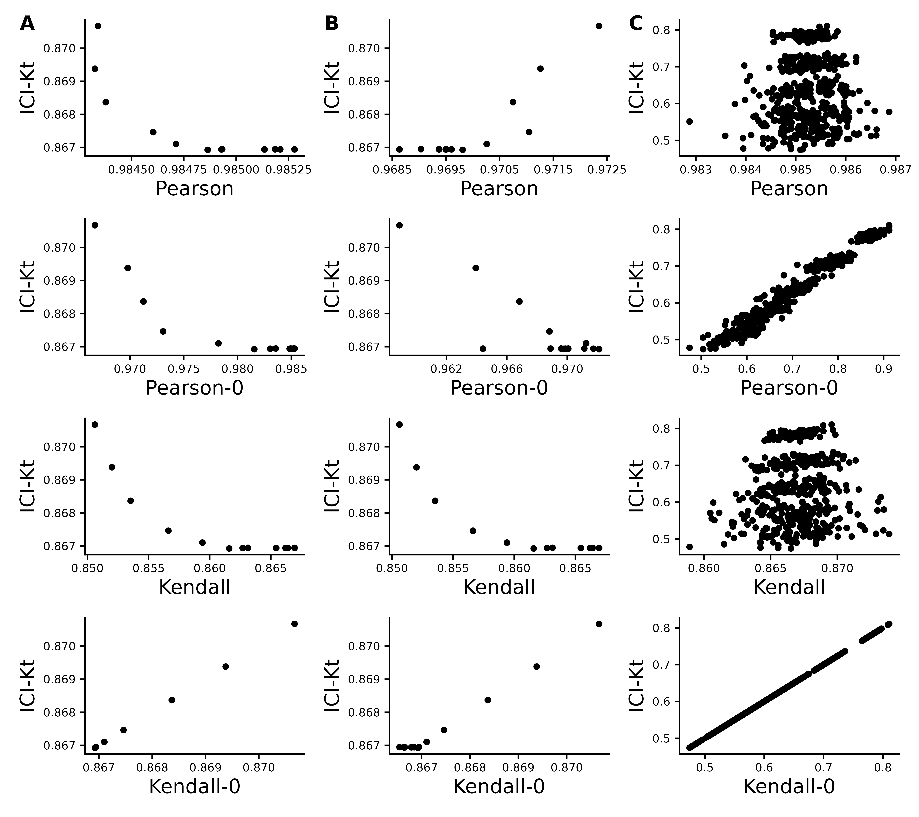

Figure S10. Effect of introducing missing values from a cutoff (A & B) or randomly (C) on different measures of correlation, including ICI-Kt, Kendall with pairwise complete, Kendall replacing missing with 0, Pearson with pairwise complete, and Pearson replacing missing with 0. A) Missing values introduced by setting an increasing cutoff. B) Missing values introduced by setting an increasing cutoff, and then log-transforming the values before calculating correlation. C) Missing values introduced at random. For the random case, each sample of random positions was repeated 100 times.

## Performance

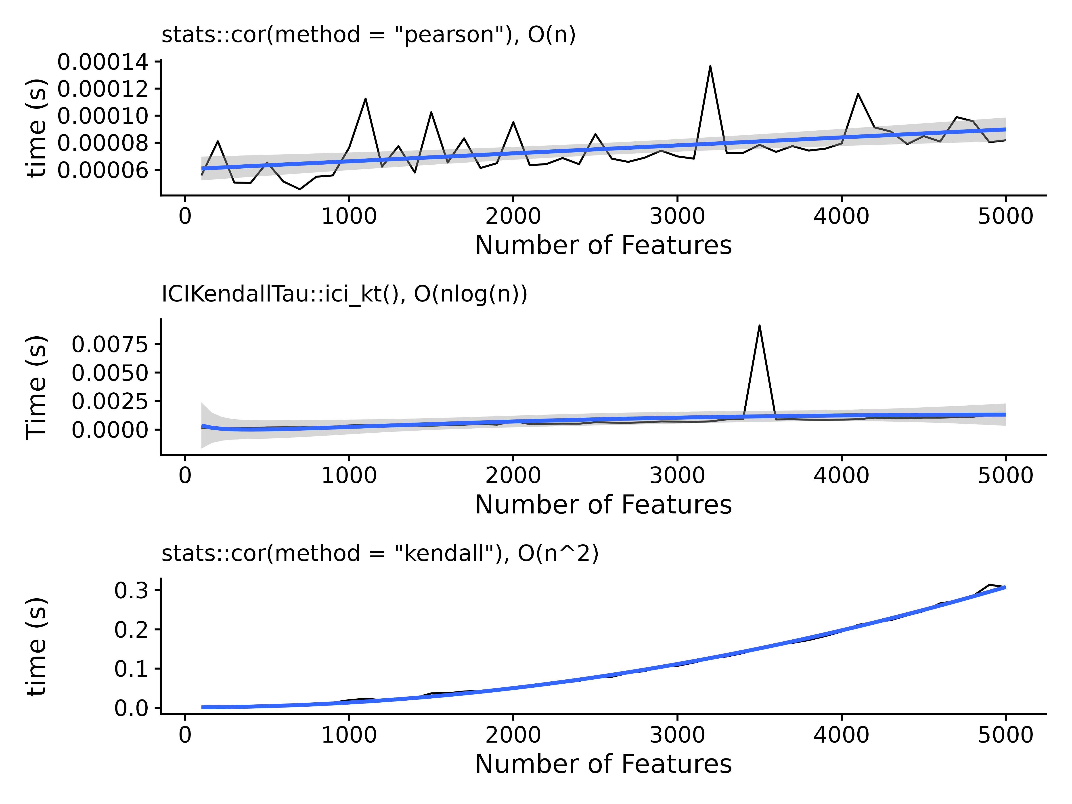

Figure S11. Time in seconds needed as a function of the number of features, with a fitted line for the assumed complexity for each of the methods tested, including R’s Pearson correlation, the ICI-Kt mergesort, and R’s Kendall-tau correlation algorithm.

## Outlier Samples

### Gierlinski Yeast

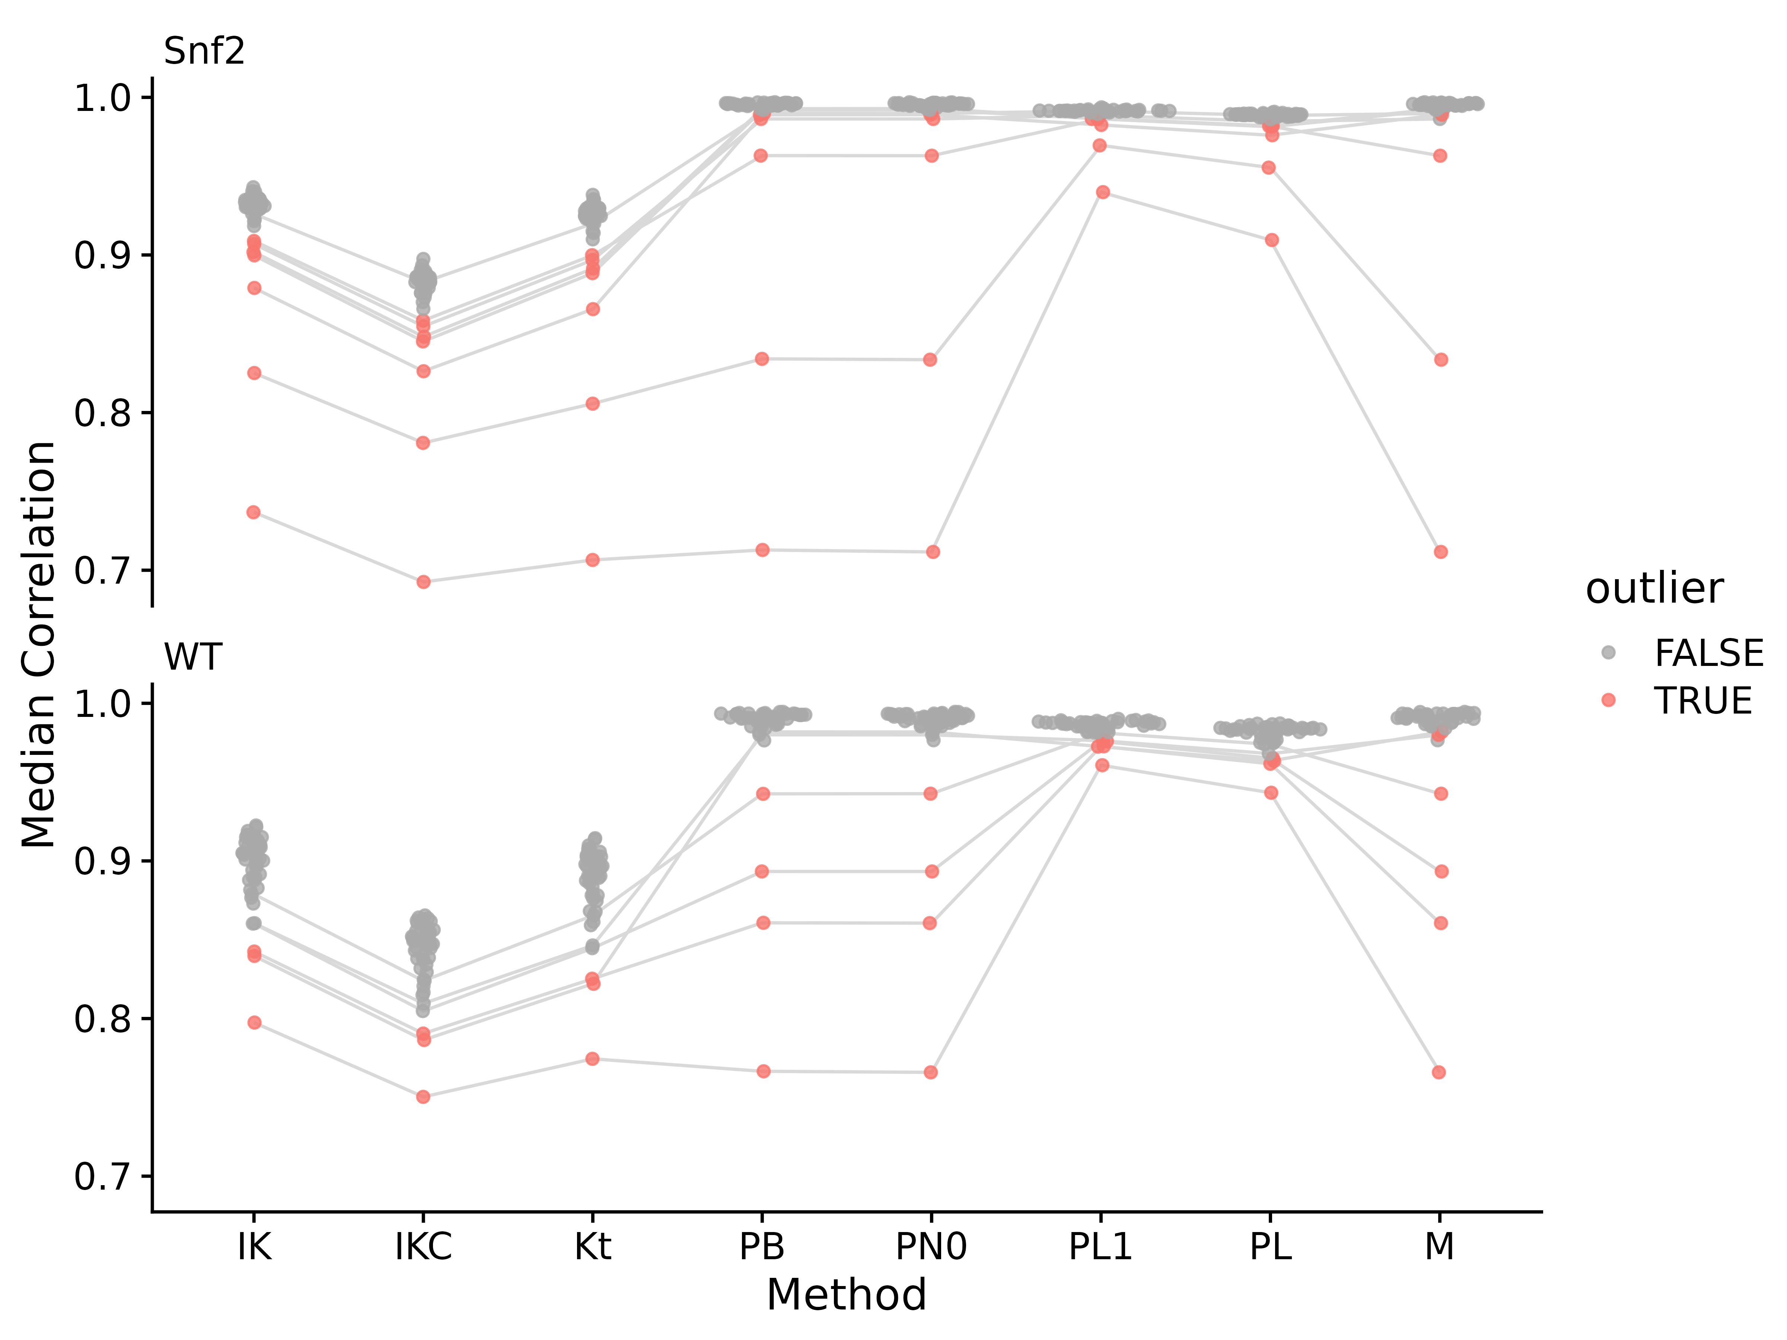

Figure S12. Median correlations for each of the yeast RNA-Seq samples to all other samples in the same group, using different correlation measures on different data. Abbreviations for different measures and data are: IK: ICI-Kt; IKC: ICI-Kt * Completeness; M: Manuscript; PL1: Pearson Log(x + 1); PN0: Pearson No Zeros. Points are colored red if they were an outlier using that correlation method. For a sample that is considered an outlier in any of the method, lines are drawn connecting them between methods.

Table S1. Yeast dataset median correlation values and outlier determination for each outlier from each of the correlation methods. Abbreviations for different measures are: IK: ICI-Kt; IKC: ICI-Kt * Completeness; PB: Pearson Base, PN: Pearson No Zero; PL1: Pearson Log(x + 1); PL: Pearson Log(x); Kt: Kendall-tau.

| Sample | IK | IKC | Kt | PB | PN0 | PL1 | PL | M |
| --- | --- | --- | --- | --- | --- | --- | --- | --- |
| Snf2.31 | **0.902** | **0.848** | **0.891** | 0.993 | 0.993 | **0.987** | **0.982** | 0.993 |
| Snf2.15 | **0.900** | **0.845** | **0.888** | 0.992 | 0.992 | **0.986** | **0.981** | 0.992 |
| Snf2.24 | 0.926 | 0.883 | 0.920 | **0.990** | **0.990** | 0.991 | 0.988 | 0.990 |
| Snf2.25 | **0.879** | **0.826** | **0.866** | **0.989** | **0.989** | **0.982** | **0.976** | **0.989** |
| Snf2.10 | **0.907** | **0.855** | **0.897** | **0.986** | **0.986** | **0.989** | 0.985 | 0.986 |
| Snf2.35 | **0.909** | **0.858** | **0.900** | **0.963** | **0.963** | **0.986** | **0.982** | **0.963** |
| Snf2.13 | **0.825** | **0.781** | **0.806** | **0.834** | **0.834** | **0.970** | **0.955** | **0.834** |
| Snf2.06 | **0.737** | **0.693** | **0.707** | **0.713** | **0.712** | **0.940** | **0.909** | **0.712** |
| WT.34 | **0.840** | **0.786** | **0.822** | 0.982 | 0.982 | **0.973** | **0.963** | **0.982** |
| WT.36 | 0.860 | 0.810 | 0.846 | 0.980 | 0.980 | **0.976** | 0.968 | **0.980** |
| WT.22 | 0.879 | 0.824 | 0.865 | **0.943** | **0.943** | 0.981 | 0.974 | **0.943** |
| WT.28 | 0.860 | 0.805 | 0.845 | **0.893** | **0.893** | **0.976** | **0.965** | **0.893** |
| WT.25 | **0.843** | **0.790** | **0.825** | **0.861** | **0.861** | **0.973** | **0.962** | **0.861** |
| WT.21 | **0.797** | **0.750** | **0.774** | **0.767** | **0.766** | **0.961** | **0.943** | **0.766** |

### EGFR RNASeq Genotype

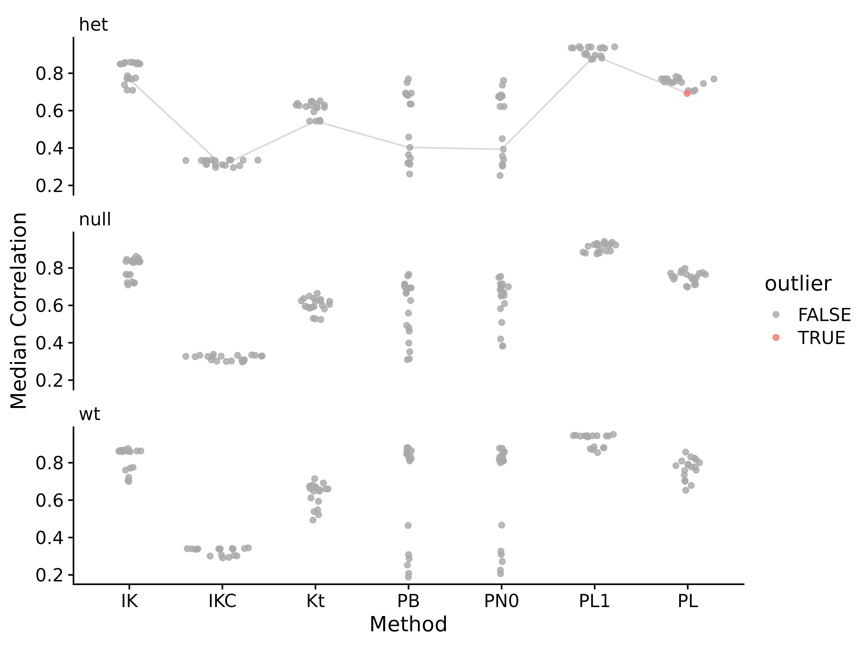

Figure S13. Median correlations for each of the Brainson RNA-Seq samples to all other samples in the same group, using different correlation measures on different data. Abbreviations for different measures and data are: IK: ICI-Kt; IKC: ICI-Kt * Completeness; PB: Pearson Base, PN: Pearson No Zero; PL1: Pearson Log(x + 1); PL: Pearson Log(x); Kt: Kendall-tau. Points are colored red if they were an outlier using that correlation method. For a sample that is considered an outlier in any of the method, lines are drawn connecting them between methods.

Table S2. EGFR RNA-Seq dataset using genotype as the grouping variable median correlation values and outlier determination for each outlier from each of the correlation methods. Abbreviations for different measures and data are: IK: ICI-Kt; IKC: ICI-Kt * Completeness; PB: Pearson Base, PN: Pearson No Zero; PL1: Pearson Log(x + 1); PL: Pearson Log(x); Kt: Kendall-tau.

| Sample | IK | IKC | Kt | PB | PN0 | PL1 | PL |
| --- | --- | --- | --- | --- | --- | --- | --- |
| 783-het.sorted | 0.768 | 0.307 | 0.544 | 0.403 | 0.394 | 0.893 | **0.692** |

### TCGA Adenocarcinoma

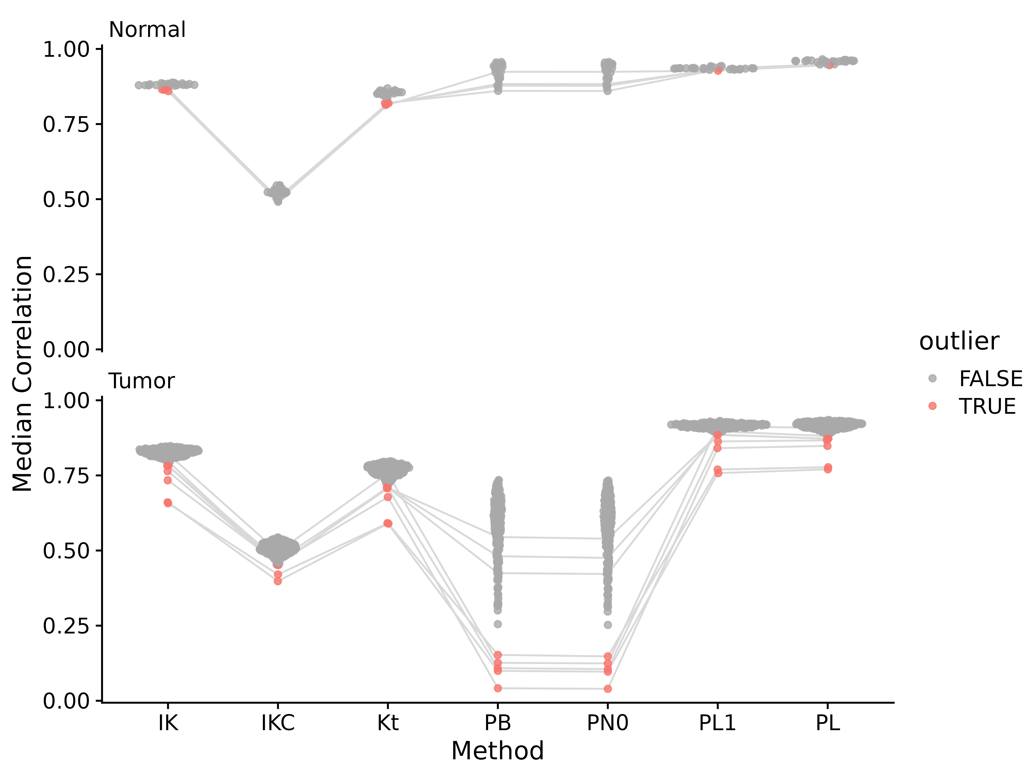

Figure S14. Median correlations for each of the TGCA adenocarcinoma RNA-Seq samples to all other samples in the same group, using different correlation measures on different data. Abbreviations for different measures and data are: IK: ICI-Kt; IKC: ICI-Kt * Completeness; PB: Pearson Base, PN: Pearson No Zero; PL1: Pearson Log(x + 1); PL: Pearson Log(x); Kt: Kendall-tau. Points are colored red if they were an outlier using that correlation method. For a sample that is considered an outlier in any of the method, lines are drawn connecting them between methods.

Table S3. TGCA adenocarcinoma dataset median correlation values and outlier determination for each outlier from each of the correlation methods. Abbreviations for different measures and data are: IK: ICI-Kt; IKC: ICI-Kt * Completeness; PB: Pearson Base, PN: Pearson No Zero; PL1: Pearson Log(x + 1); PL: Pearson Log(x); Kt: Kendall-tau.

| Sample | IK | IKC | Kt | PB | PN0 | PL1 | PL |
| --- | --- | --- | --- | --- | --- | --- | --- |
| N.24 | **0.864** | 0.504 | **0.819** | 0.878 | 0.877 | 0.934 | 0.949 |
| N.13 | **0.865** | 0.504 | **0.818** | 0.883 | 0.883 | 0.933 | 0.949 |
| N.18 | **0.867** | 0.499 | **0.820** | 0.860 | 0.860 | 0.932 | 0.948 |
| N.22 | **0.859** | 0.495 | **0.814** | 0.924 | 0.924 | **0.928** | **0.946** |
| T.39 | 0.821 | 0.496 | 0.757 | **0.126** | **0.124** | 0.914 | 0.908 |
| T.122 | 0.798 | **0.453** | **0.710** | 0.425 | 0.422 | 0.897 | 0.881 |
| T.180 | **0.783** | 0.467 | **0.709** | 0.545 | 0.539 | **0.886** | **0.872** |
| T.220 | **0.782** | **0.452** | **0.712** | 0.481 | 0.475 | **0.885** | **0.872** |
| T.38 | **0.764** | 0.454 | **0.707** | **0.109** | **0.105** | **0.863** | **0.867** |
| T.261 | **0.734** | 0.459 | **0.678** | **0.042** | **0.040** | **0.841** | **0.848** |
| T.40 | **0.657** | **0.420** | **0.591** | **0.153** | **0.148** | **0.770** | **0.777** |
| T.260 | **0.661** | **0.398** | **0.590** | **0.099** | **0.097** | **0.758** | **0.770** |

Table S4. Adenocarcinoma median-absolute-deviations (MAD) for each group of sample median correlations in each type of tissue.

| method | Normal | Tumor |
| --- | --- | --- |
| IK | 0.004 | 0.012 |
| IKC | 0.011 | 0.019 |
| Kt | 0.008 | 0.019 |
| PB | 0.022 | 0.092 |
| PN0 | 0.021 | 0.091 |
| PL1 | 0.002 | 0.008 |
| PL | 0.003 | 0.012 |

### NSCLC Lipidomics

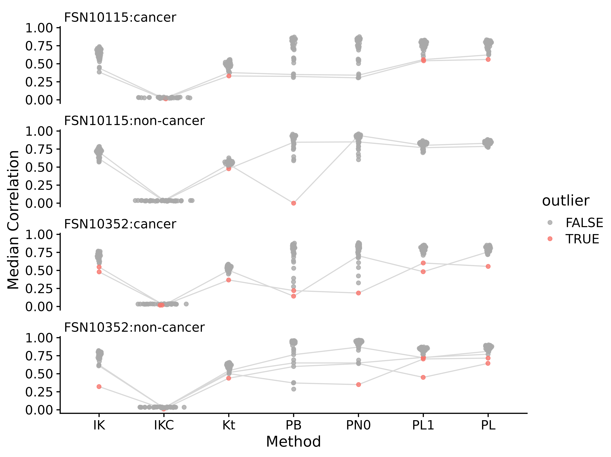

Figure S15. Median correlations for each of the NSCLC lipidomics samples to all other samples in the same group, using different correlation measures on different data. Abbreviations for different measures and data are: IK: ICI-Kt; IKC: ICI-Kt * Completeness; PB: Pearson Base, PN: Pearson No Zero; PL1: Pearson Log(x + 1); PL: Pearson Log(x); Kt: Kendall-tau. Points are colored red if they were an outlier using that correlation method. For a sample that is considered an outlier in any of the method, lines are drawn connecting them between methods.

Table S5. NSCLC lipidomics dataset median correlation values and outlier determination for each outlier from each of the correlation methods. Abbreviations for different measures and data are: IK: ICI-Kt; IKC: ICI-Kt * Completeness; PB: Pearson Base, PN: Pearson No Zero; PL1: Pearson Log(x + 1); PL: Pearson Log(x); Kt: Kendall-tau.

| Sample | IK | IKC | Kt | PB | PN0 | PL1 | PL |
| --- | --- | --- | --- | --- | --- | --- | --- |
| 172Cpos | 0.440 | 0.019 | 0.377 | 0.351 | 0.342 | **0.558** | 0.623 |
| 73Cpos | 0.385 | **0.013** | **0.331** | 0.324 | 0.305 | **0.541** | **0.560** |
| 73Npos | 0.708 | 0.037 | 0.538 | **-0.000** | 0.939 | 0.802 | 0.830 |
| 78Npos | 0.615 | 0.032 | **0.477** | 0.845 | 0.849 | 0.769 | 0.787 |
| uk003cposb | **0.547** | **0.018** | **0.367** | **0.220** | **0.187** | **0.603** | **0.556** |
| 47Cpos | **0.480** | **0.019** | 0.501 | **0.143** | 0.703 | **0.482** | 0.758 |
| 155Nposr | 0.609 | 0.025 | 0.517 | 0.650 | 0.650 | **0.727** | 0.771 |
| 201Npos | 0.621 | 0.026 | 0.542 | 0.764 | 0.870 | **0.722** | 0.811 |
| 169Npos | 0.621 | 0.026 | 0.502 | 0.372 | **0.350** | **0.705** | **0.717** |
| 148Npos | **0.322** | **0.010** | **0.438** | 0.600 | 0.640 | **0.450** | **0.644** |

### Rat Stamina Metabolomics

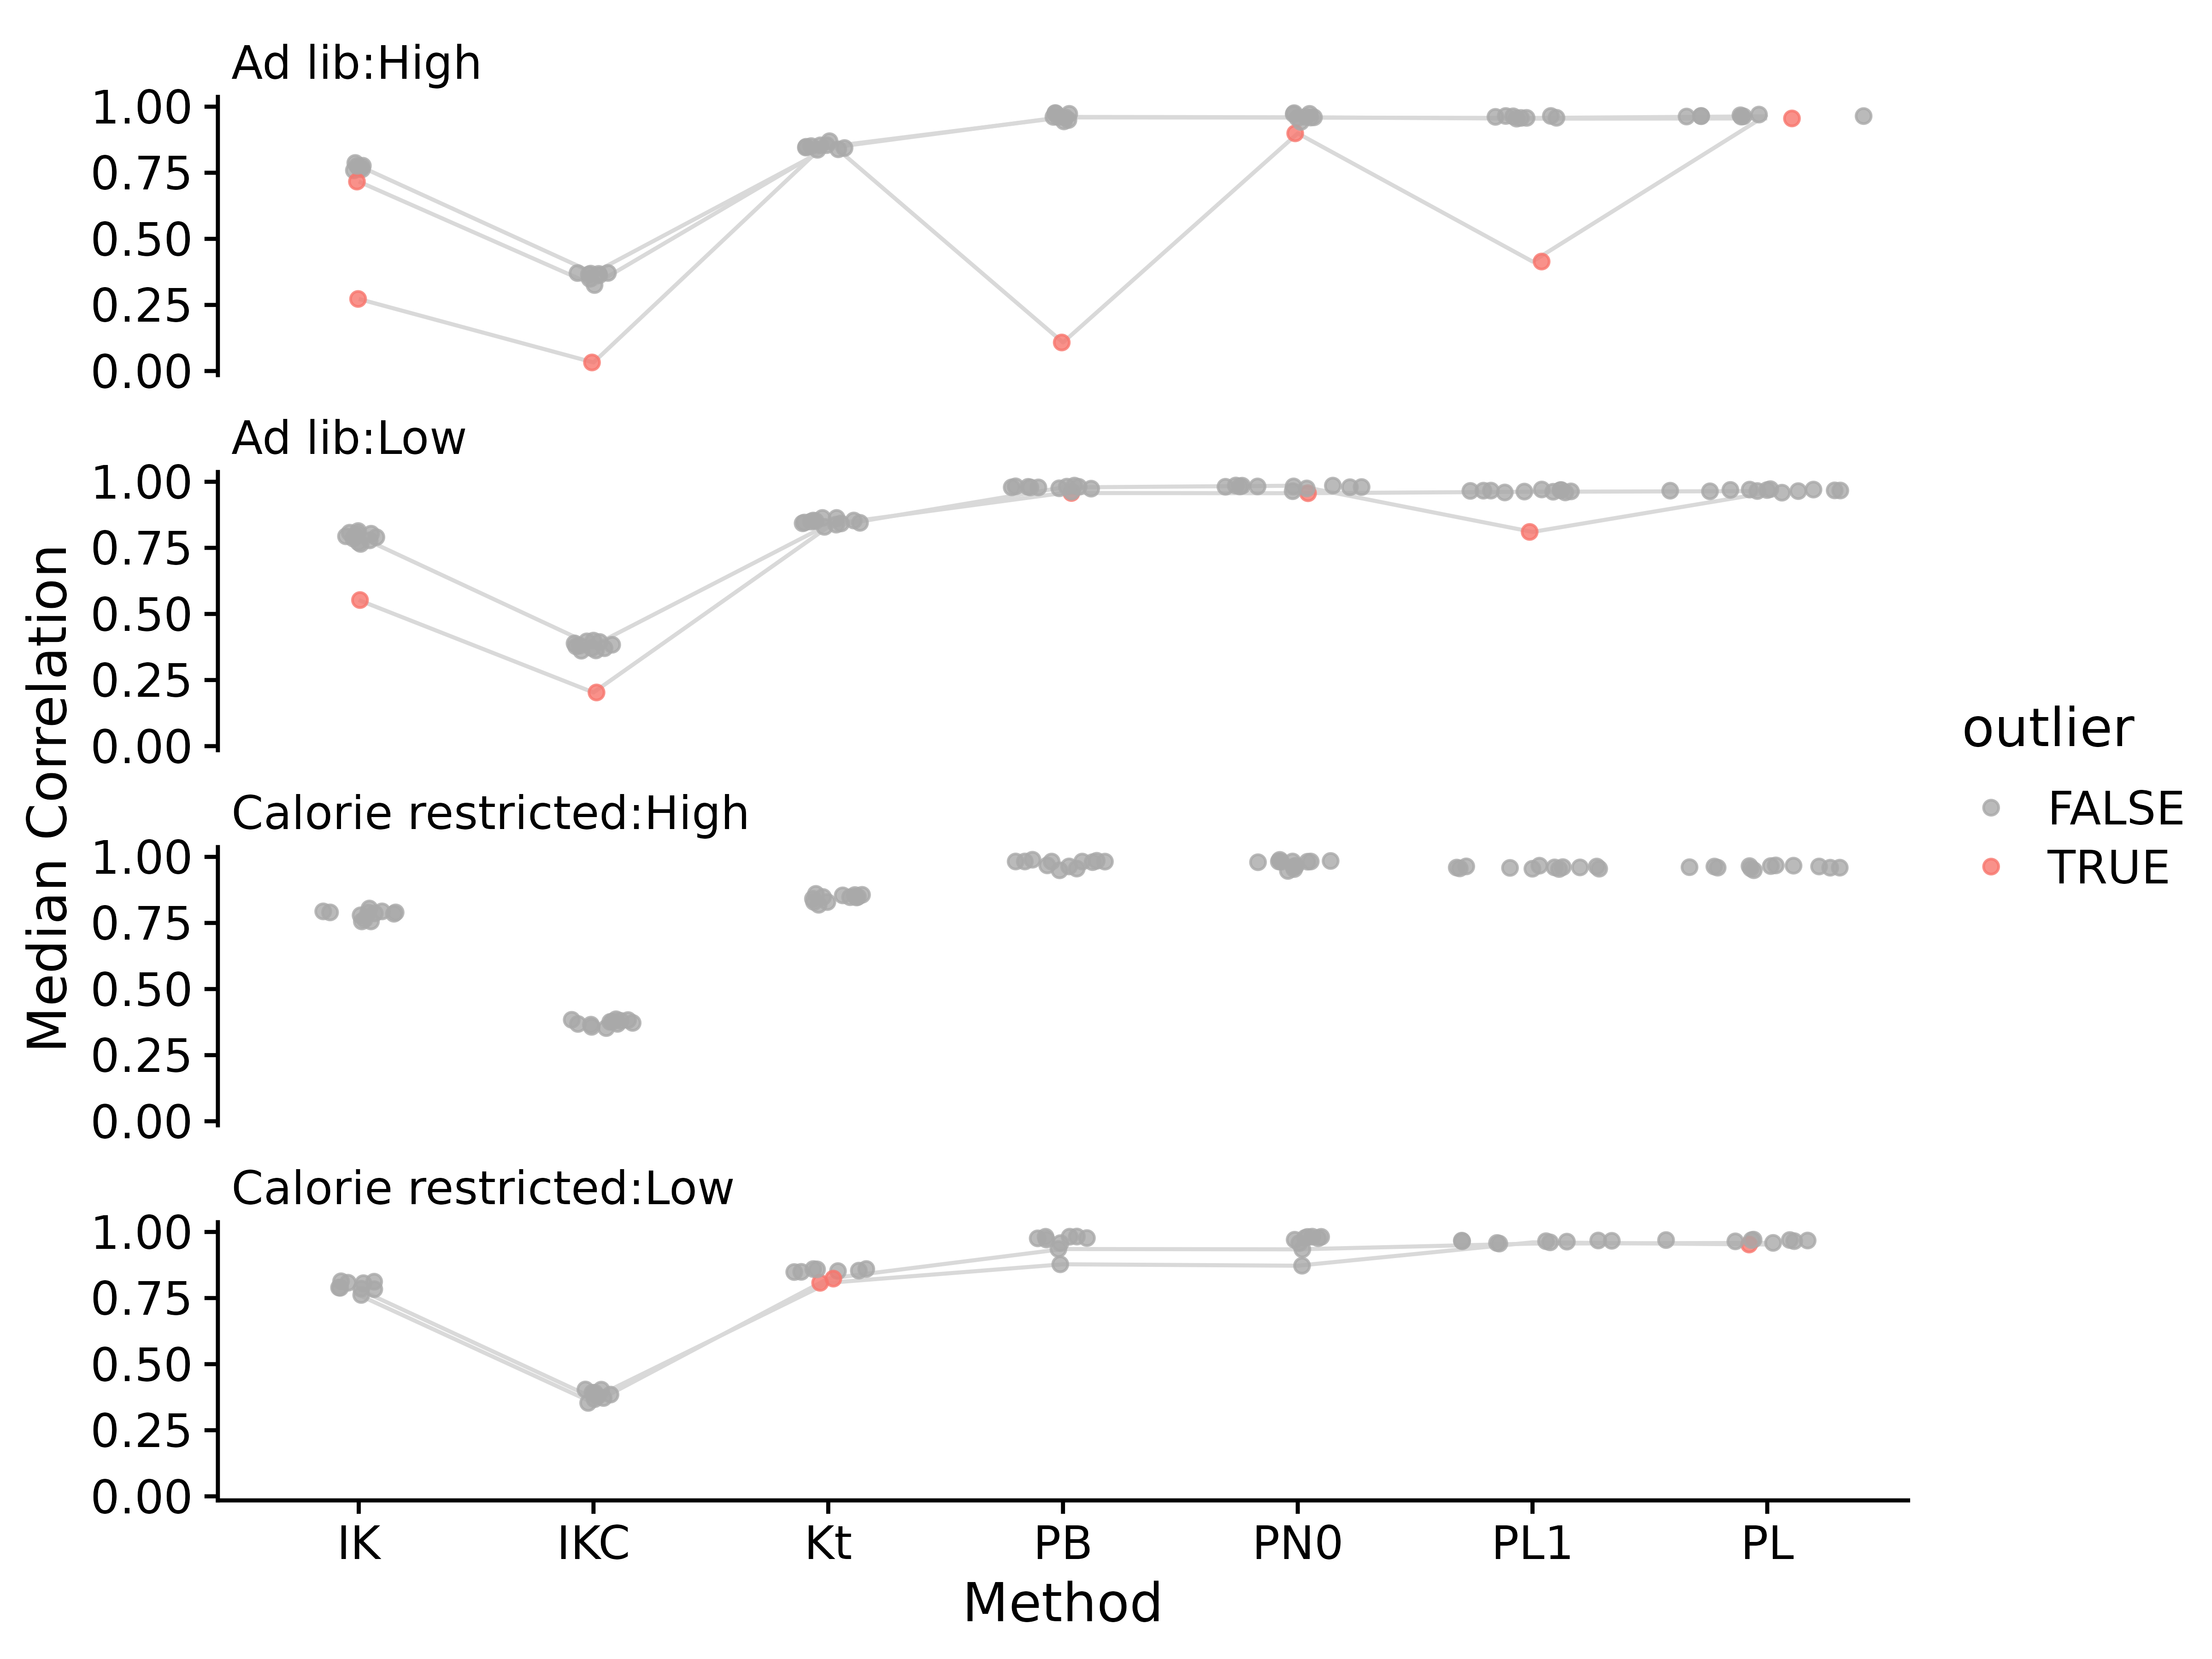

Figure S16. Median correlations for each of the rat stamina metabolomics samples to all other samples in the same group, using different correlation measures on different data. Abbreviations for different measures and data are: IK: ICI-Kt; IKC: ICI-Kt * Completeness; PB: Pearson Base, PN: Pearson No Zero; PL1: Pearson Log(x + 1); PL: Pearson Log(x); Kt: Kendall-tau. Points are colored red if they were an outlier using that correlation method. For a sample that is considered an outlier in any of the method, lines are drawn connecting them between methods.

Table S6. Rat stamina metabolomics dataset median correlation values and outlier determination for each outlier from each of the correlation methods. Abbreviations for different measures and data are: IK: ICI-Kt; IKC: ICI-Kt * Completeness; PB: Pearson Base, PN: Pearson No Zero; PL1: Pearson Log(x + 1); PL: Pearson Log(x); Kt: Kendall-tau.

| Sample | IK | IKC | Kt | PB | PN0 | PL1 | PL |
| --- | --- | --- | --- | --- | --- | --- | --- |
| s00009502 | **0.717** | 0.325 | 0.848 | 0.959 | 0.959 | 0.957 | 0.963 |
| s00009501 | 0.776 | 0.371 | 0.844 | 0.961 | 0.960 | 0.955 | **0.955** |
| s00009481 | **0.273** | **0.032** | 0.869 | **0.108** | **0.899** | **0.414** | 0.970 |
| s00009471 | 0.794 | 0.380 | 0.838 | **0.957** | **0.957** | 0.962 | 0.965 |
| s00009470 | **0.553** | **0.203** | 0.829 | 0.979 | 0.985 | **0.810** | 0.959 |
| s00009484 | 0.783 | 0.372 | **0.808** | 0.878 | 0.872 | 0.961 | **0.953** |
| s00009508 | 0.762 | 0.353 | **0.823** | 0.935 | 0.934 | 0.956 | 0.959 |

## Effect of Increasing Presence in Samples

### Yeast Samples

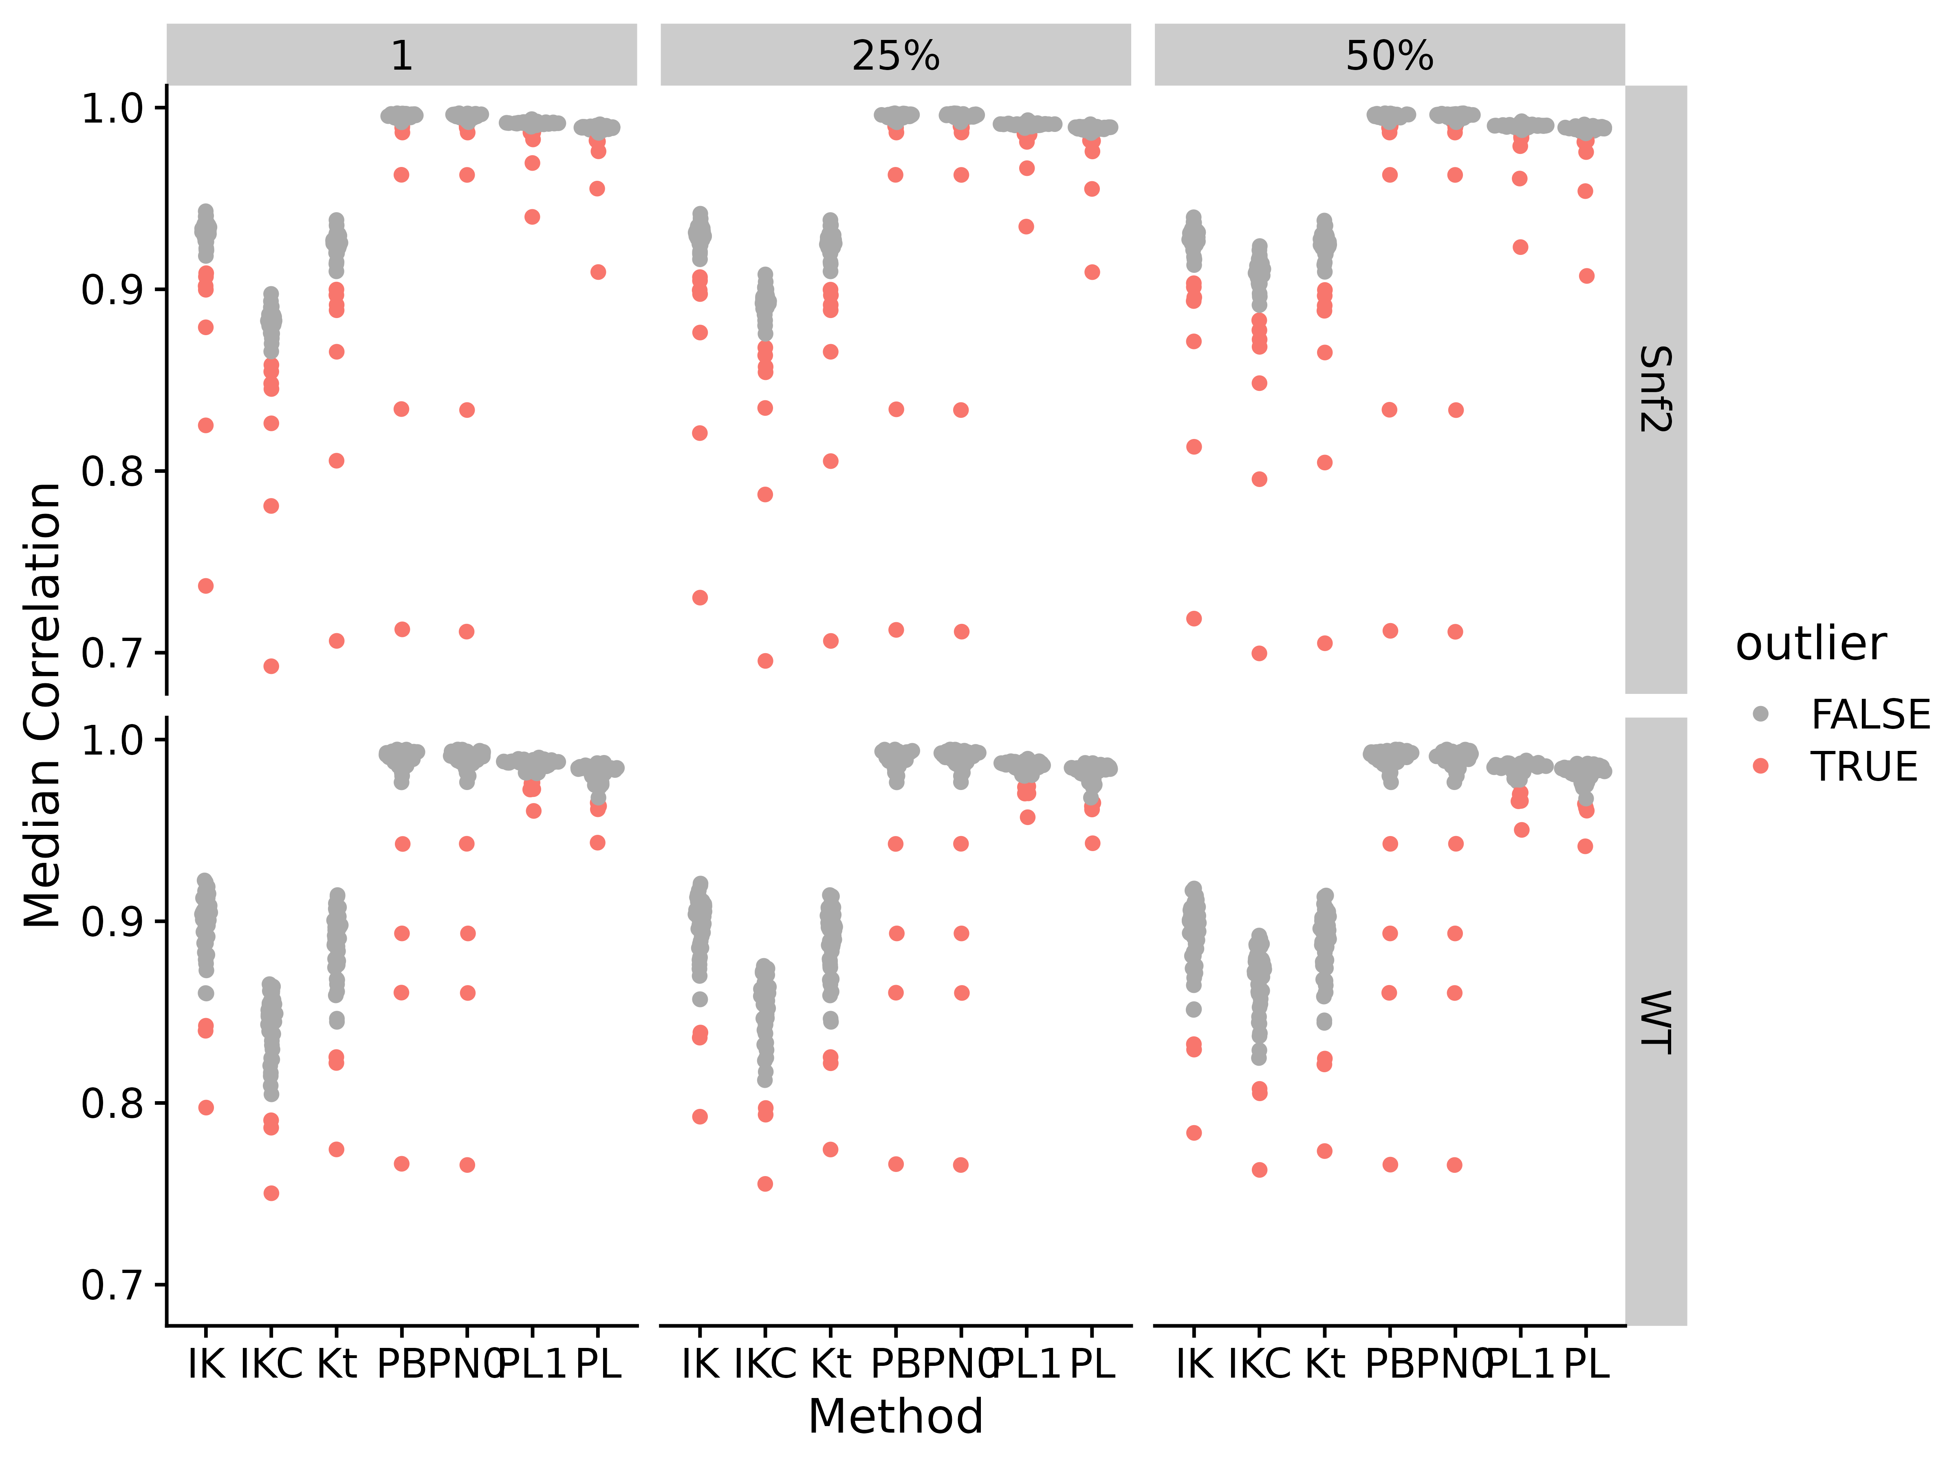

Figure S17. Median correlations by correlation method and applying different fractional cutoffs. Abbreviations for different measures and data are: IK: ICI-Kt; IKC: ICI-Kt * Completeness; Kt: Kendall-tau; PB: Pearson Base (raw values); PL: Pearson Log(x); PL1: Pearson Log(x + 1); PN0: Pearson No Zeros.

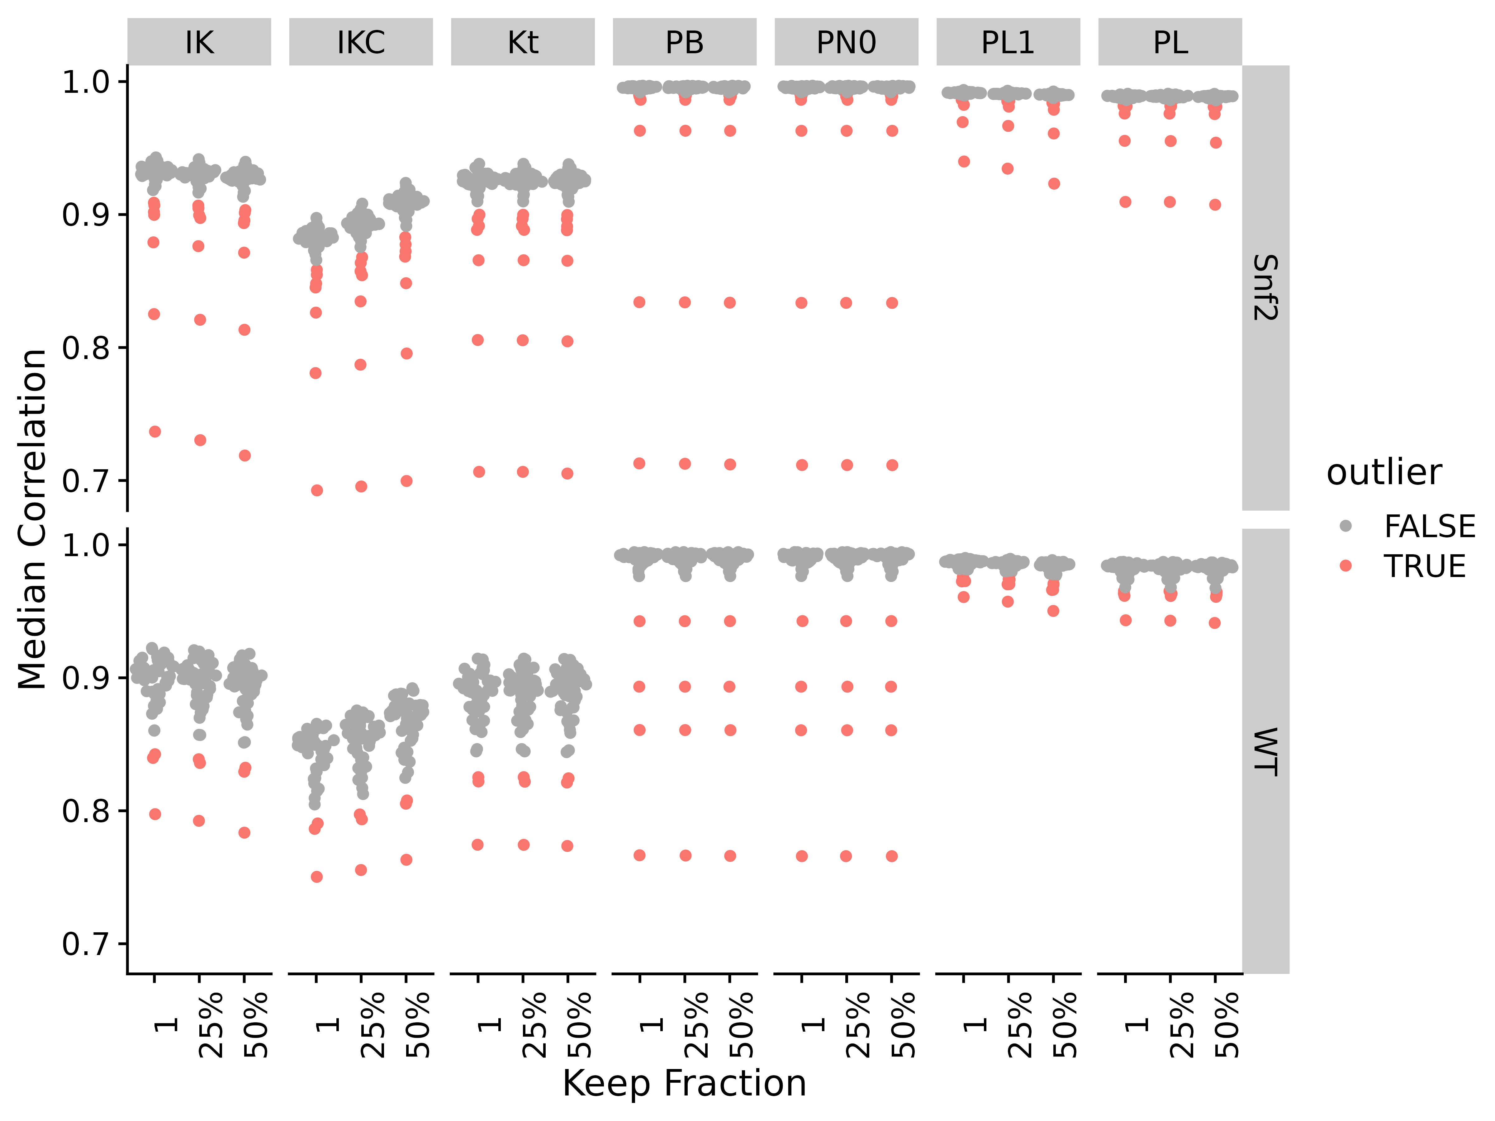

Figure S18. Median correlations by applying different fractional cutoffs and different correlation methods. Abbreviations for different measures and data are: IK: ICI-Kt; IKC: ICI-Kt * Completeness; Kt: Kendall-tau; PB: Pearson Base (raw values); PL: Pearson Log(x); PL1: Pearson Log(x + 1); PN0: Pearson No Zeros.

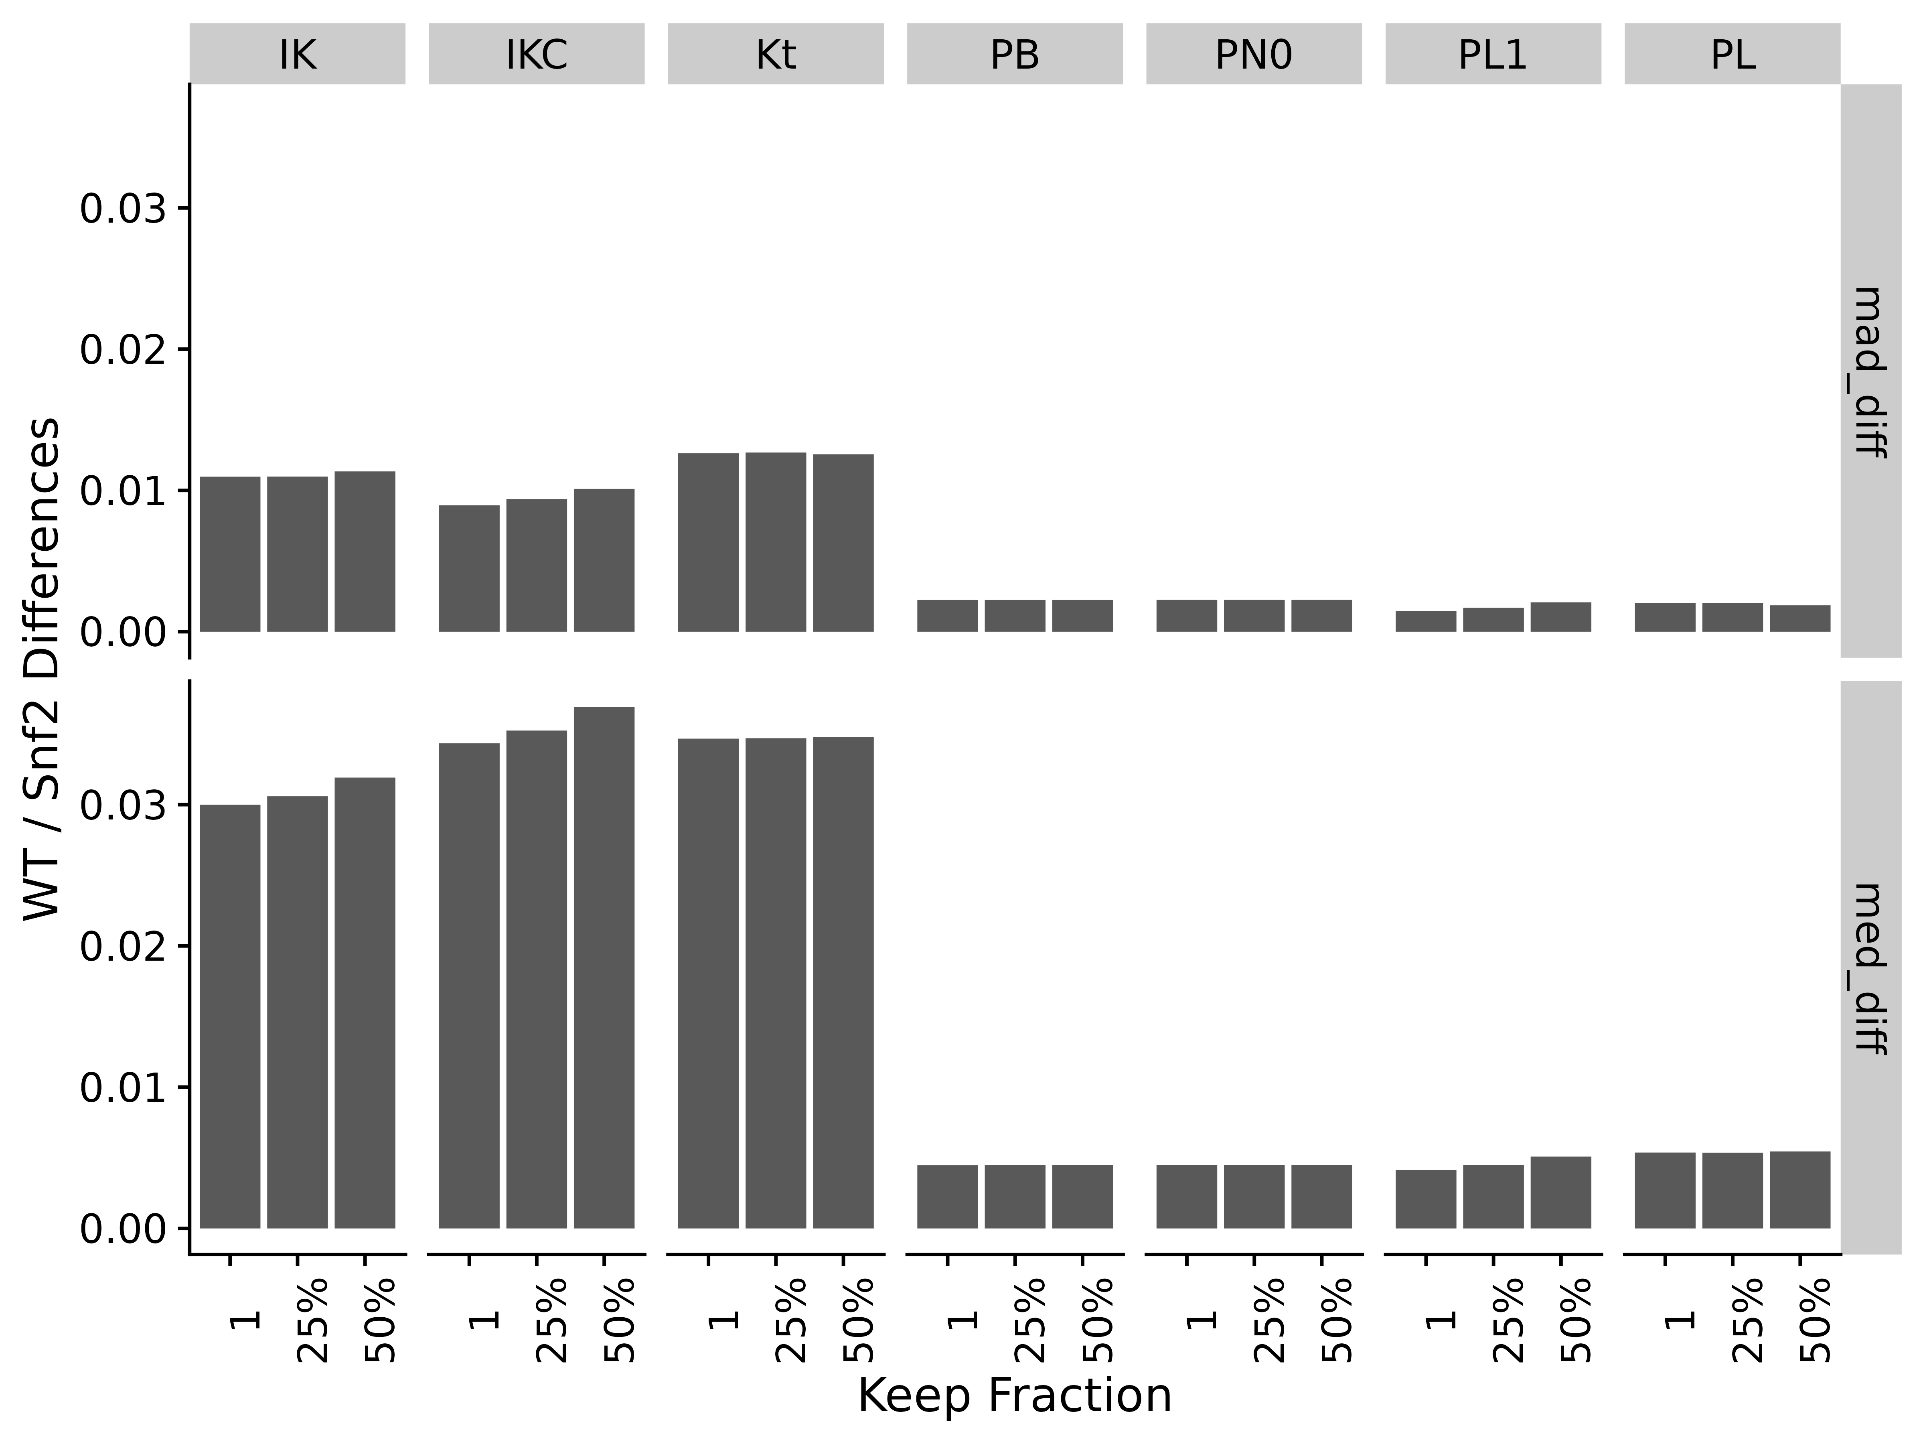

Figure S19. Difference between WT and Snf2 group medians and MAD for the different correlation methods and gene presence fractions. Abbreviations for different measures and data are: IK: ICI-Kt; IKC: ICI-Kt * Completeness; Kt: Kendall-tau; PB: Pearson Base (raw values); PL: Pearson Log(x); PL1: Pearson Log(x + 1); PN0: Pearson No Zeros.

### EGFR Genotype Samples

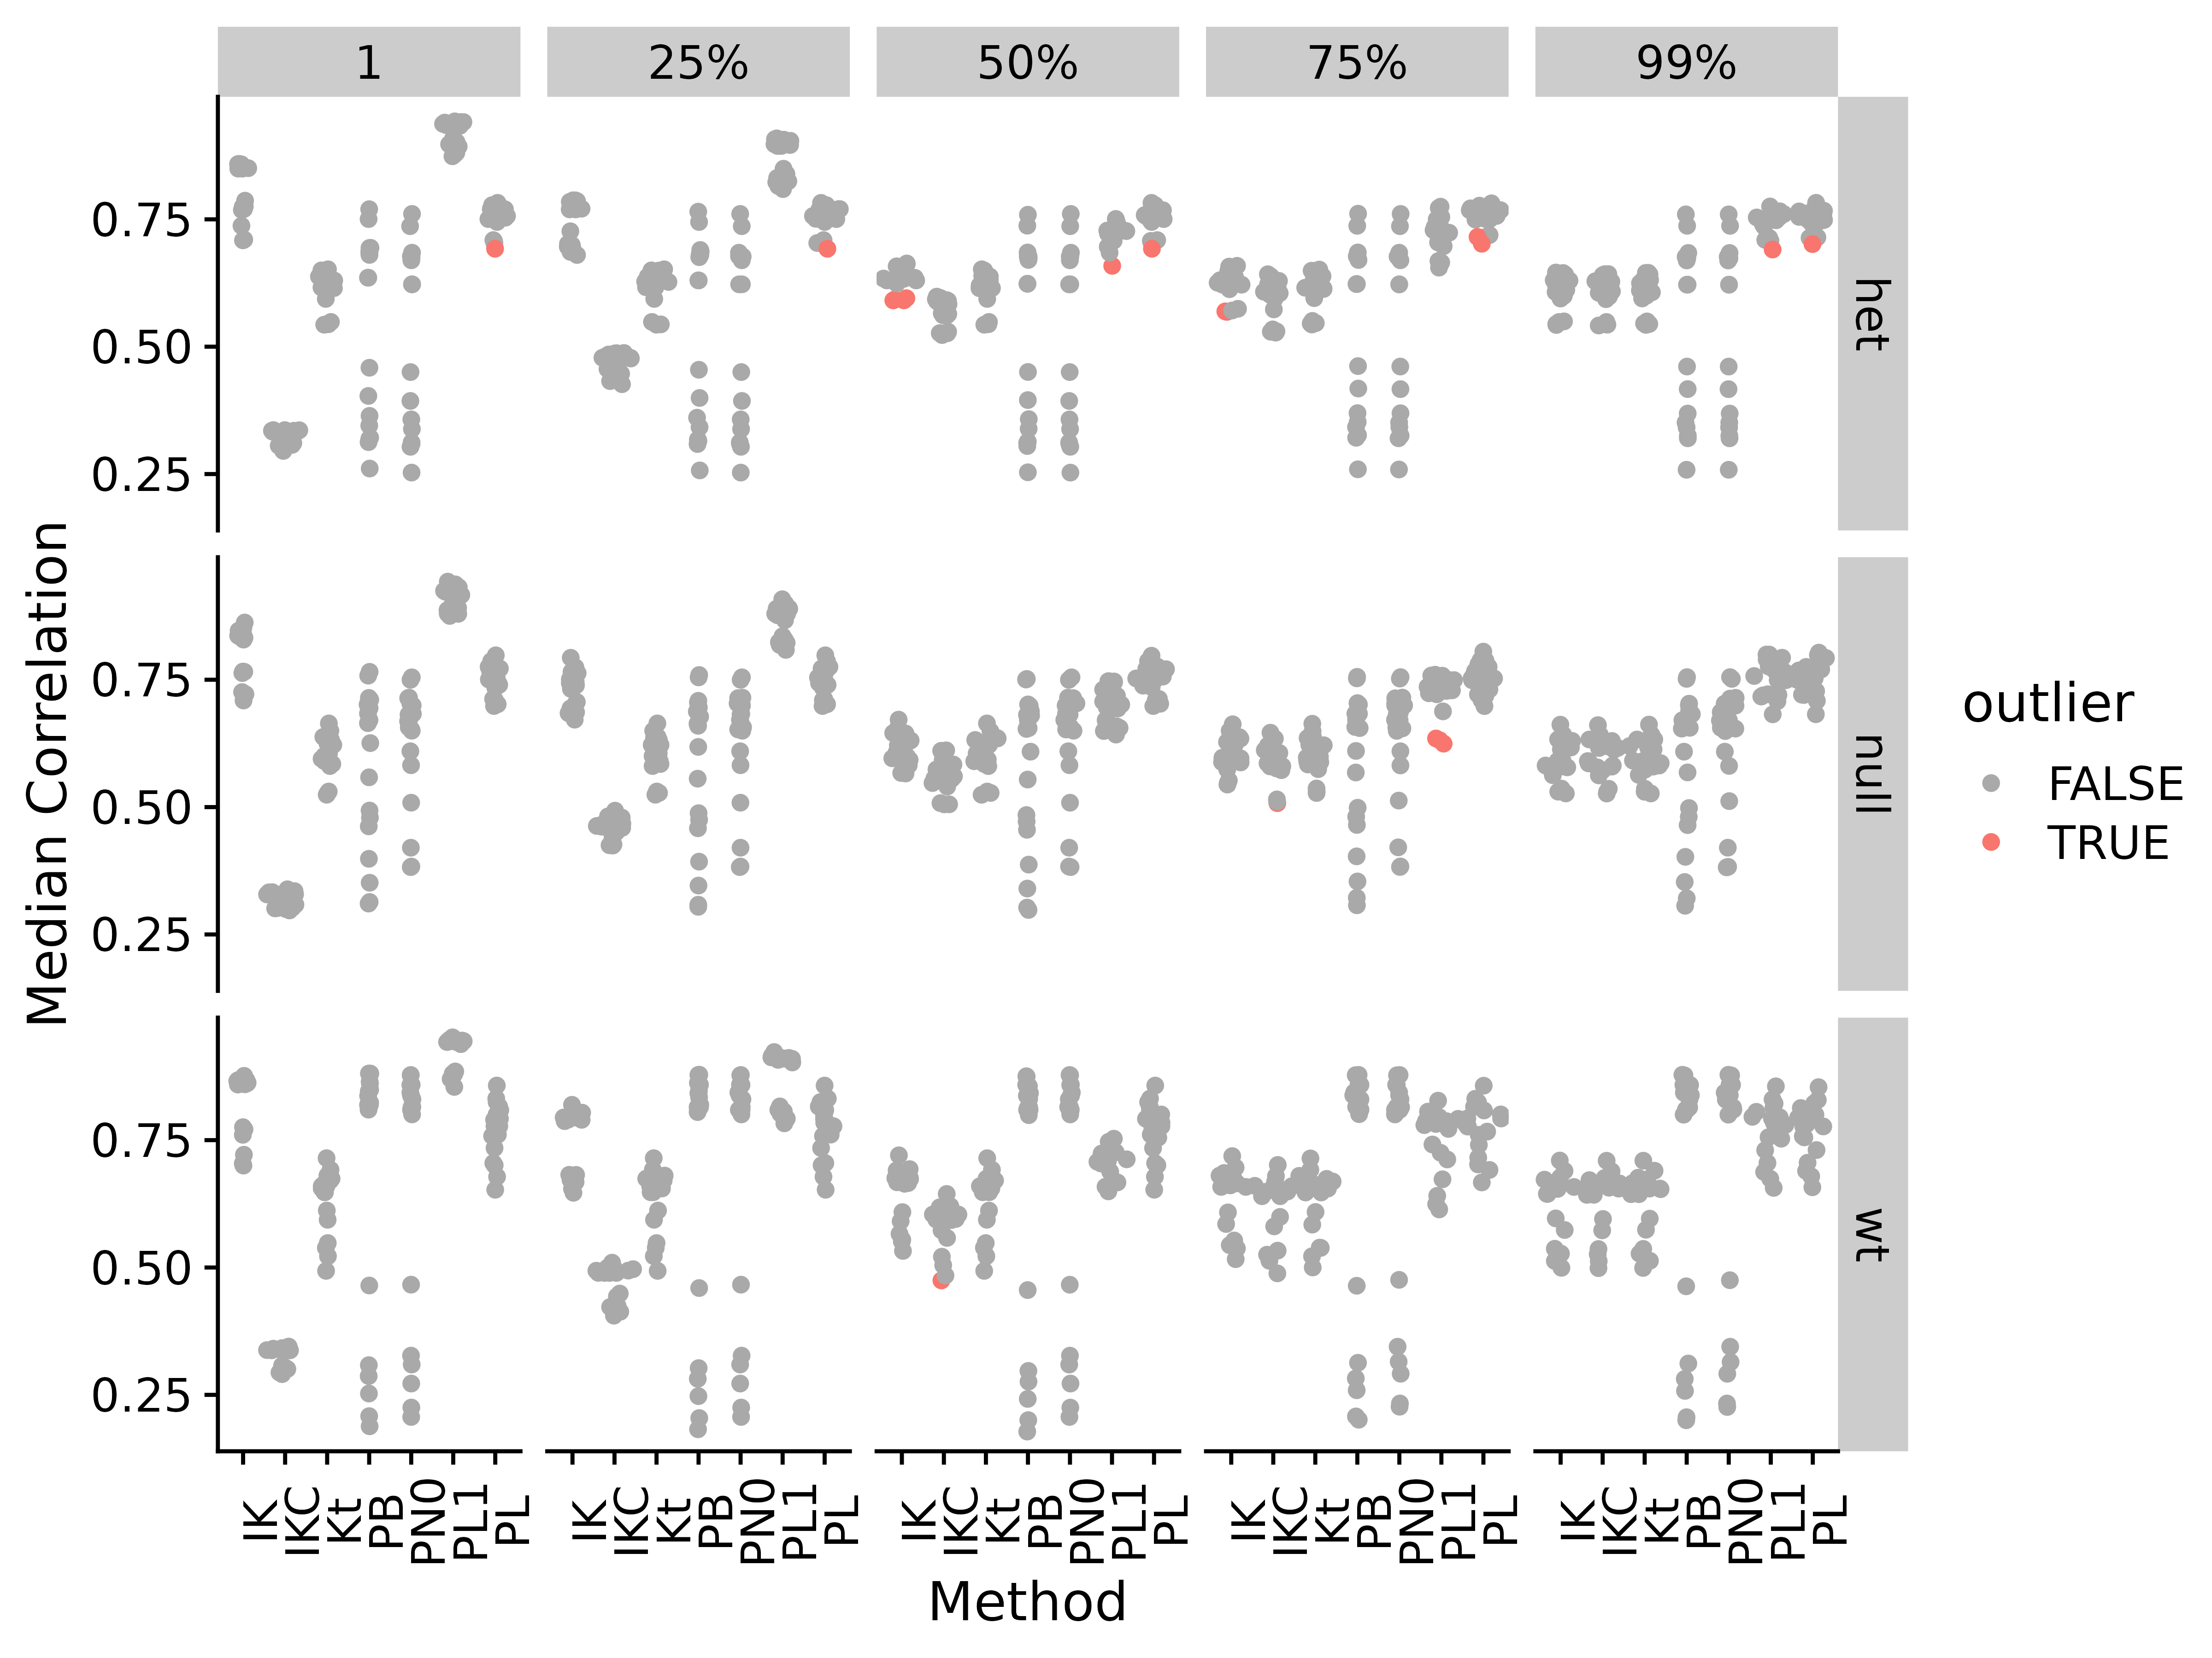

Figure S20. Median correlations by correlation method and applying different fractional cutoffs for Brainson RNA-seq data. Abbreviations for different measures and data are: IK: ICI-Kt; IKC: ICI-Kt * Completeness; Kt: Kendall-tau; PB: Pearson Base (raw values); PL: Pearson Log(x); PL1: Pearson Log(x + 1); PN0: Pearson No Zeros.

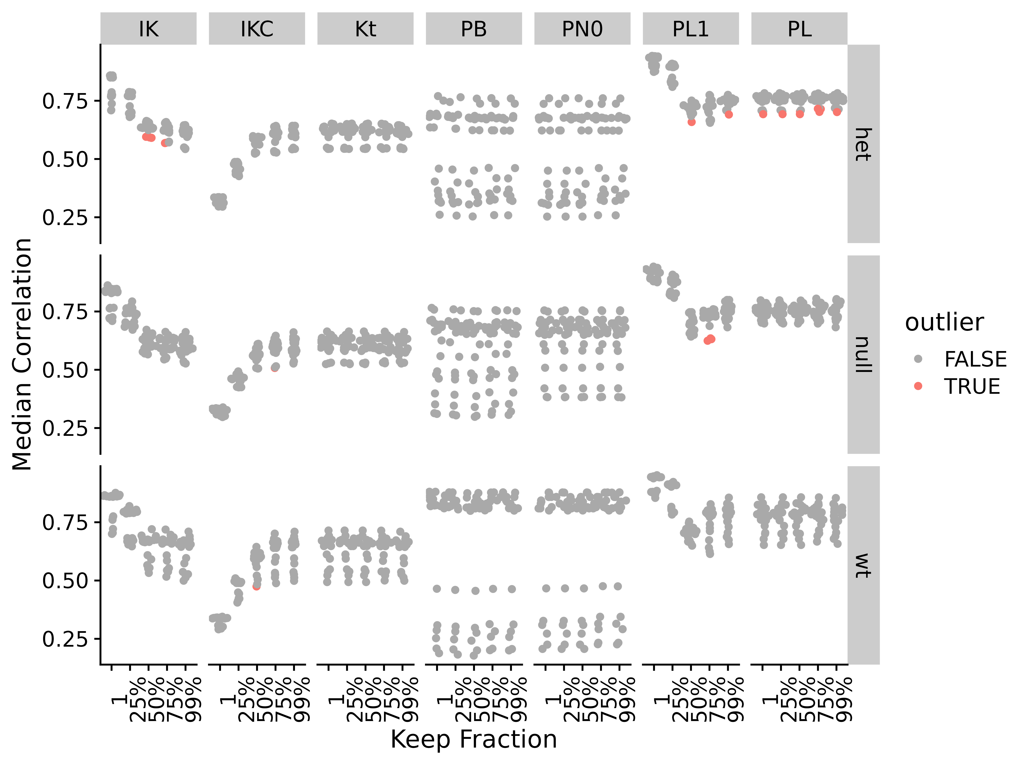

Figure S21. Median correlations by correlation method and applying different fractional cutoffs for Brainson RNA-seq data. Abbreviations for different measures and data are: IK: ICI-Kt; IKC: ICI-Kt * Completeness; Kt: Kendall-tau; PB: Pearson Base (raw values); PL: Pearson Log(x); PL1: Pearson Log(x + 1); PN0: Pearson No Zeros.

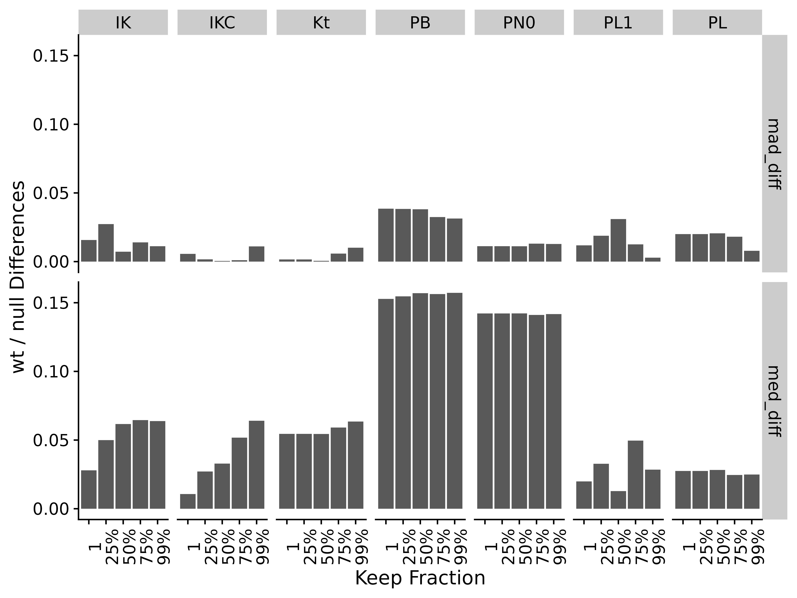

Figure S22. Difference between *wt* and *null* sample group medians and MAD for the different correlation methods and gene presence fractions. Abbreviations for different measures and data are: IK: ICI-Kt; IKC: ICI-Kt * Completeness; Kt: Kendall-tau; PB: Pearson Base (raw values); PL: Pearson Log(x); PL1: Pearson Log(x + 1); PN0: Pearson No Zeros.

### Adenocarcinoma

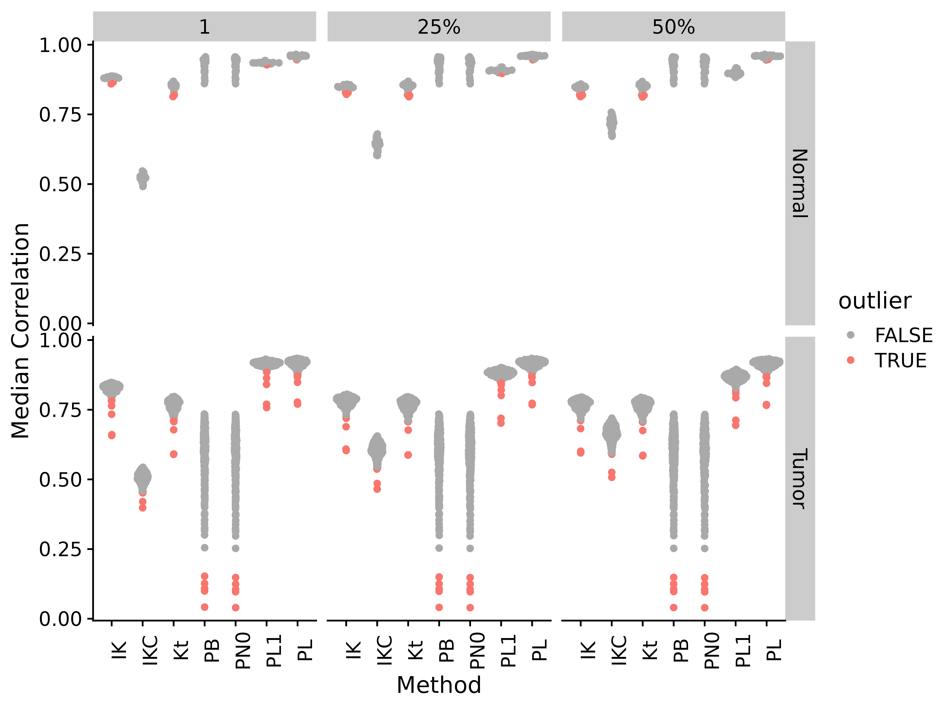

Figure S23. Median correlations by correlation method and applying different fractional cutoffs for TCGA adenocarcinoma RNA-seq data. Abbreviations for different measures and data are: IK: ICI-Kt; IKC: ICI-Kt * Completeness; Kt: Kendall-tau; PB: Pearson Base (raw values); PL: Pearson Log(x); PL1: Pearson Log(x + 1); PN0: Pearson No Zeros.

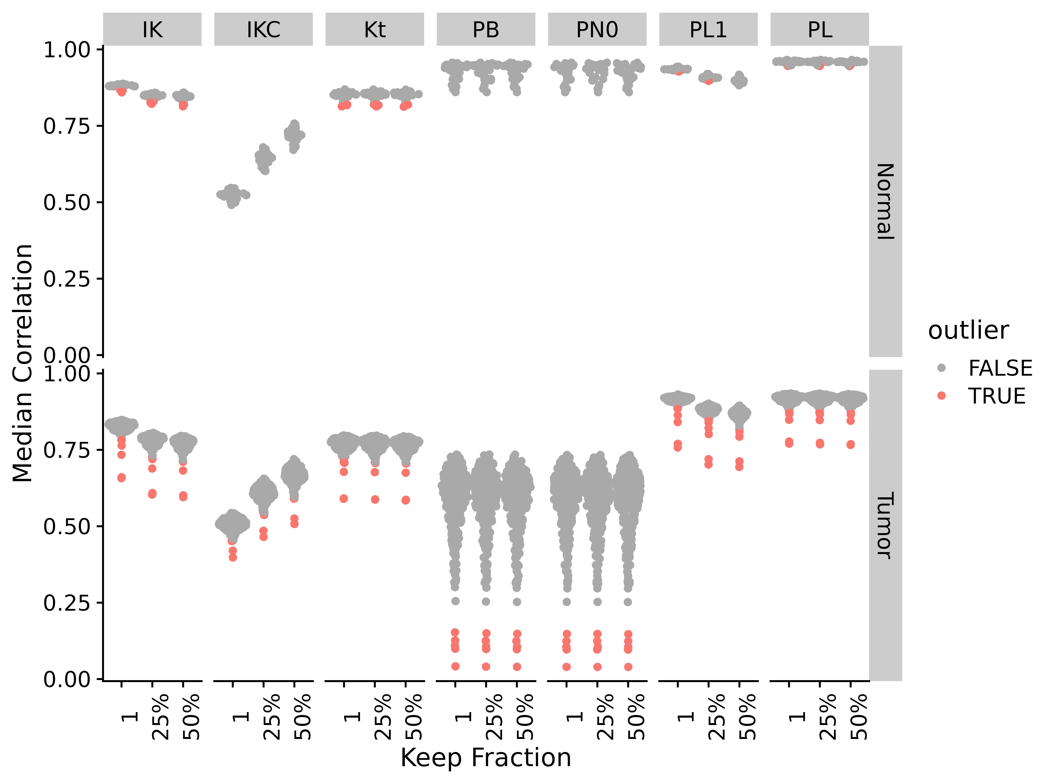

Figure S24. Median correlations by correlation method and applying different fractional cutoffs for TCGA adenocarcinoma RNA-seq data. Abbreviations for different measures and data are: IK: ICI-Kt; IKC: ICI-Kt * Completeness; Kt: Kendall-tau; PB: Pearson Base (raw values); PL: Pearson Log(x); PL1: Pearson Log(x + 1); PN0: Pearson No Zeros.

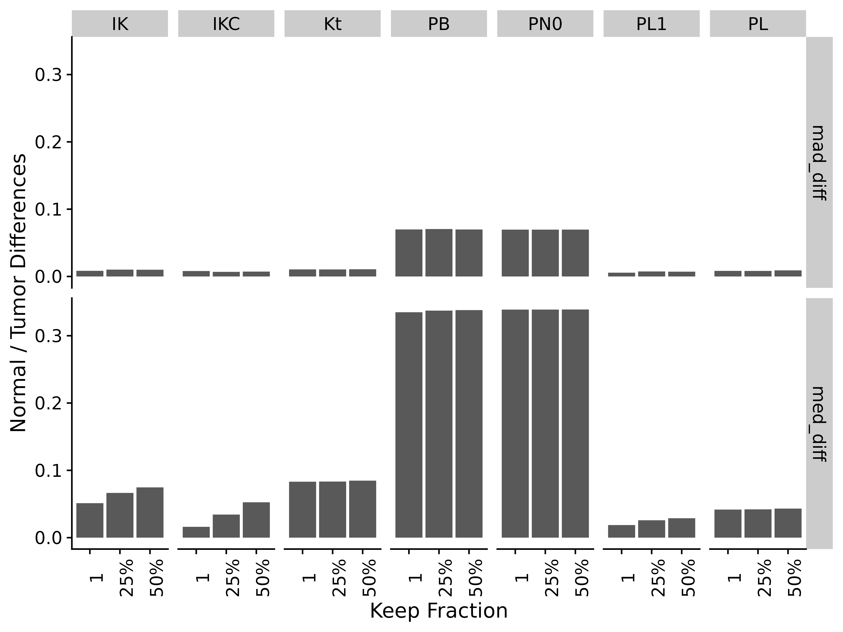

Figure S25. Difference of normal and tumor medians and MADs by correlation method and applying different fractional cutoffs for TCGA adenocarcinoma RNA-seq data. Abbreviations for different measures and data are: IK: ICI-Kt; IKC: ICI-Kt * Completeness; Kt: Kendall-tau; PB: Pearson Base (raw values); PL: Pearson Log(x); PL1: Pearson Log(x + 1); PN0: Pearson No Zeros.

### NSCLC

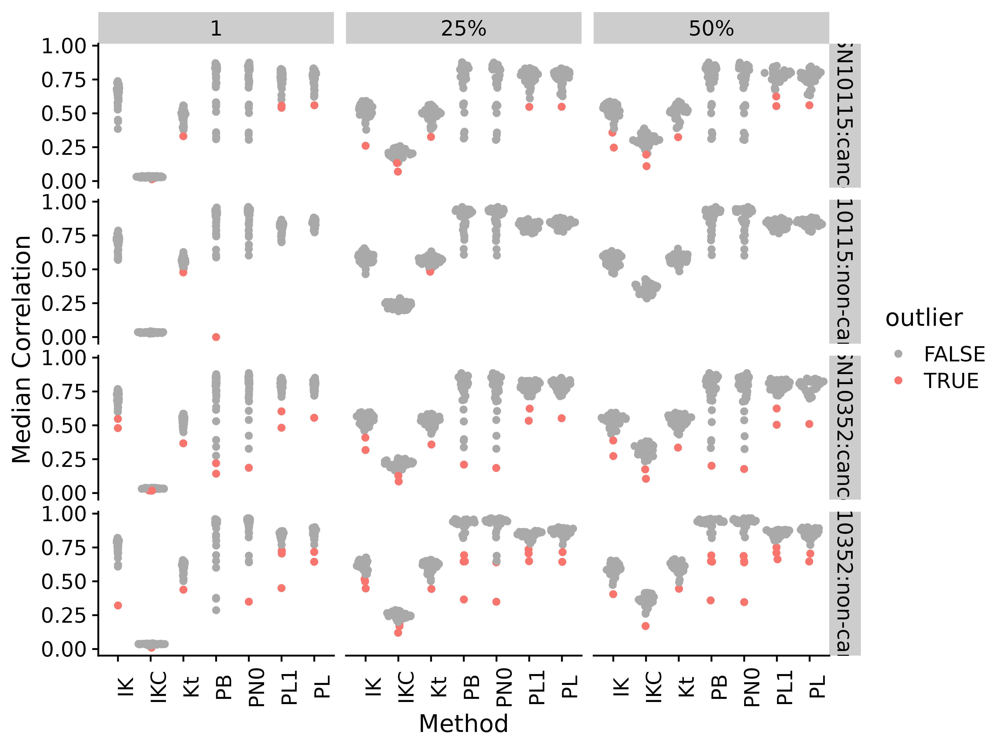

Figure S26. Median correlations by correlation method and applying different fractional cutoffs for NSCLC lipidomics data. Abbreviations for different measures and data are: IK: ICI-Kt; IKC: ICI-Kt * Completeness; Kt: Kendall-tau; PB: Pearson Base (raw values); PL: Pearson Log(x); PL1: Pearson Log(x + 1); PN0: Pearson No Zeros.

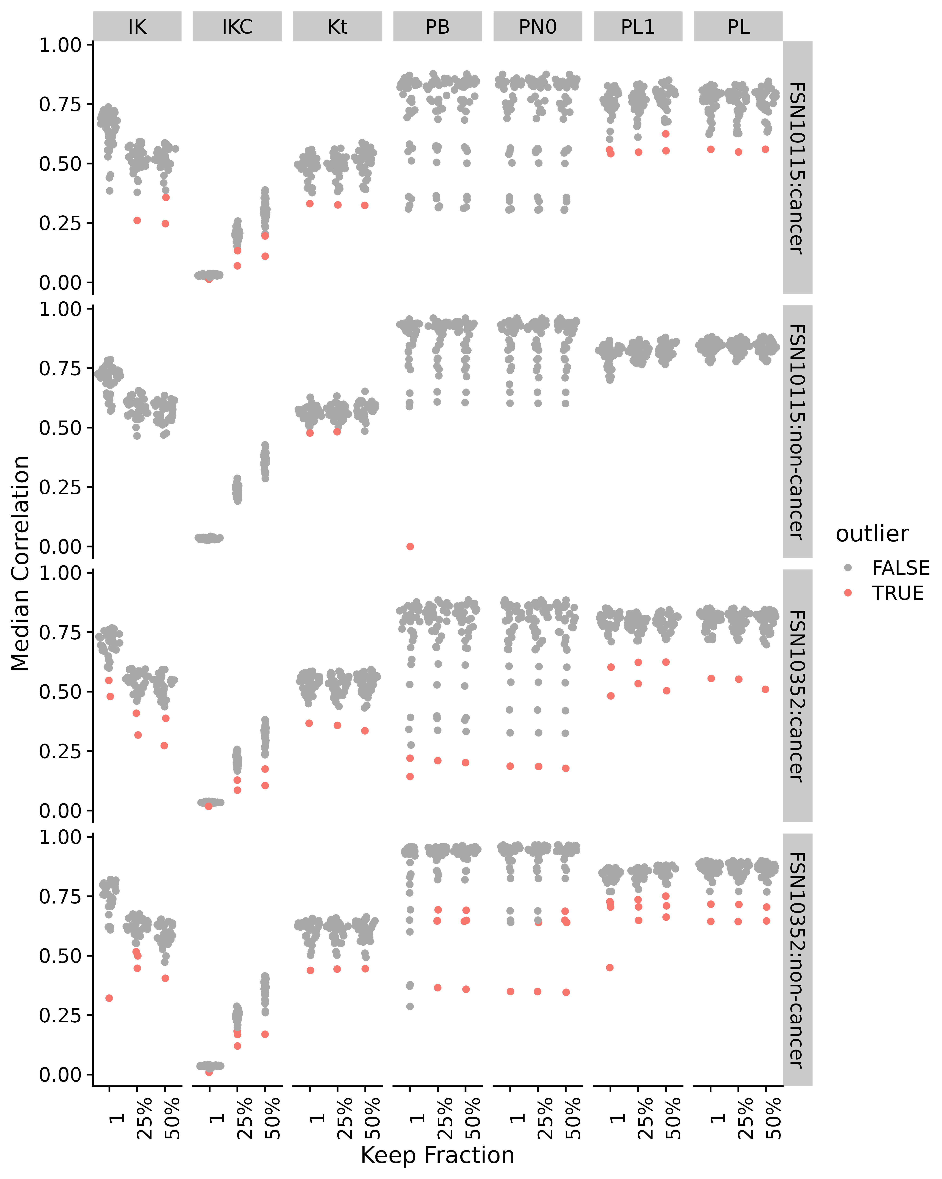

Figure S27. Median correlations by correlation method and applying different fractional cutoffs for NSCLC lipidomics data. Abbreviations for different measures and data are: IK: ICI-Kt; IKC: ICI-Kt * Completeness; Kt: Kendall-tau; PB: Pearson Base (raw values); PL: Pearson Log(x); PL1: Pearson Log(x + 1); PN0: Pearson No Zeros.

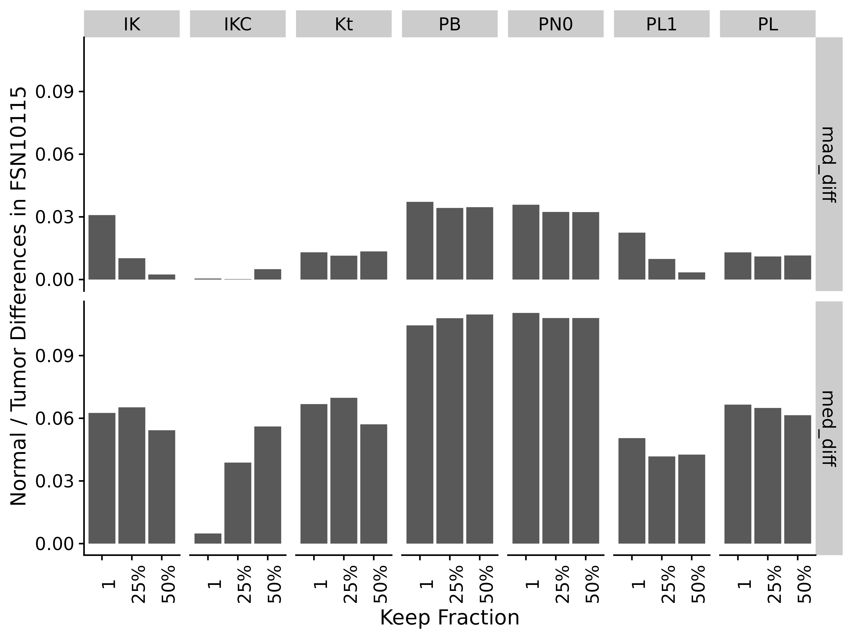

Figure S28. Difference of normal and tumor medians and MADs by correlation method and applying different fractional cutoffs for NSCLC lipidomics data. Abbreviations for different measures and data are: IK: ICI-Kt; IKC: ICI-Kt * Completeness; Kt: Kendall-tau; PB: Pearson Base (raw values); PL: Pearson Log(x); PL1: Pearson Log(x + 1); PN0: Pearson No Zeros.

### Rat Stamina

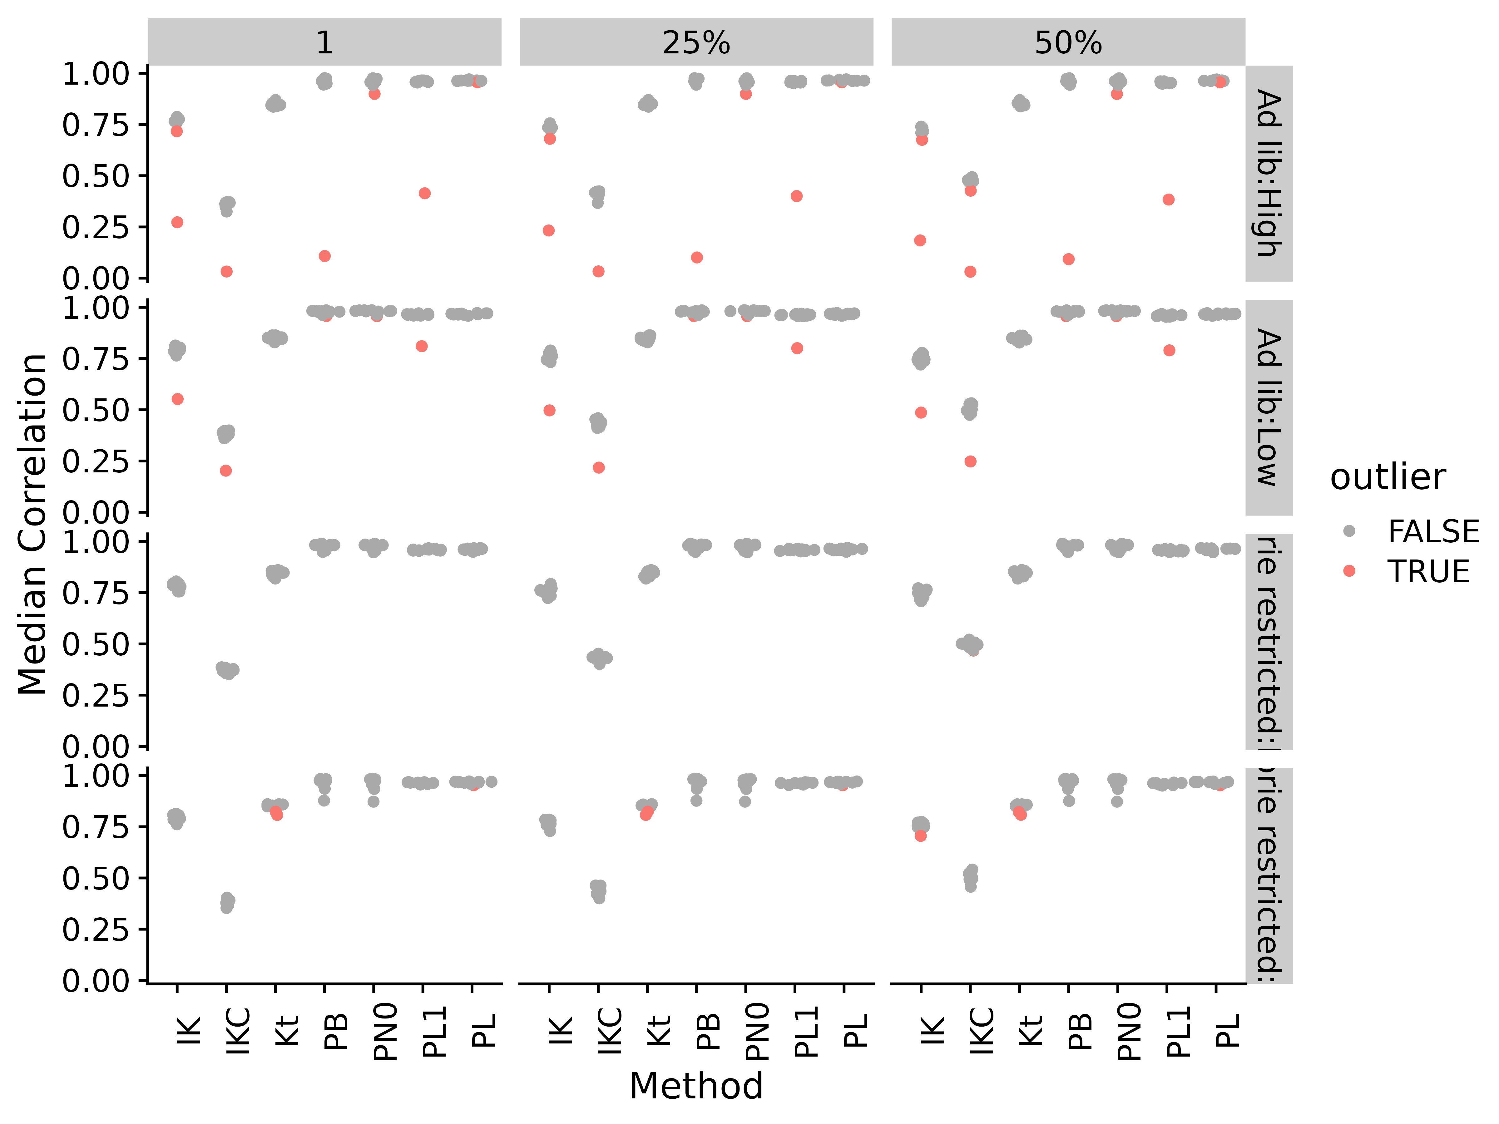

Figure S29. Median correlations by correlation method and applying different fractional cutoffs for rat stamina metabolomics data. Abbreviations for different measures and data are: IK: ICI-Kt; IKC: ICI-Kt * Completeness; Kt: Kendall-tau; PB: Pearson Base (raw values); PL: Pearson Log(x); PL1: Pearson Log(x + 1); PN0: Pearson No Zeros.

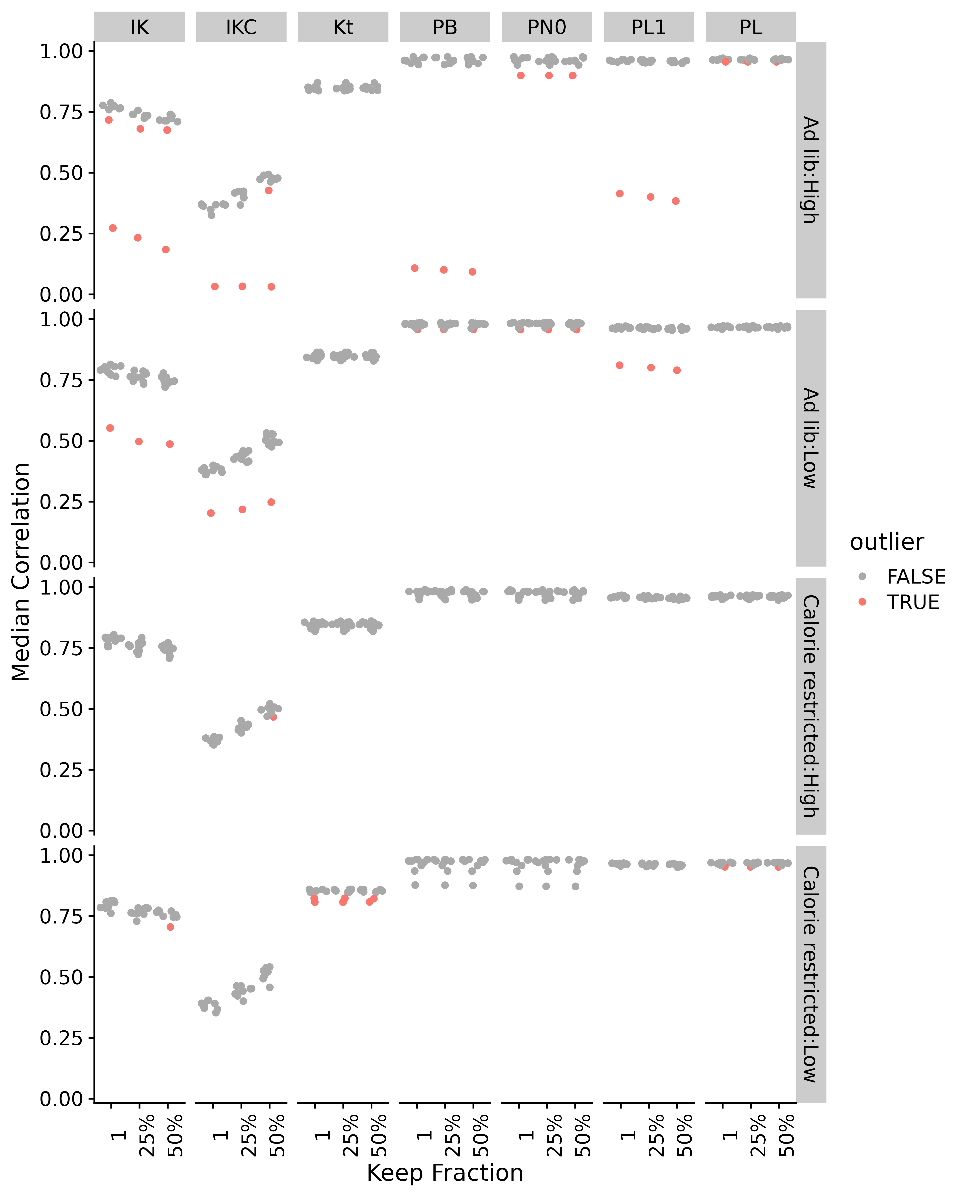

Figure S30. Median correlations by correlation method and applying different fractional cutoffs for rat stamina metabolomics data. Abbreviations for different measures and data are: IK: ICI-Kt; IKC: ICI-Kt * Completeness; Kt: Kendall-tau; PB: Pearson Base (raw values); PL: Pearson Log(x); PL1: Pearson Log(x + 1); PN0: Pearson No Zeros.

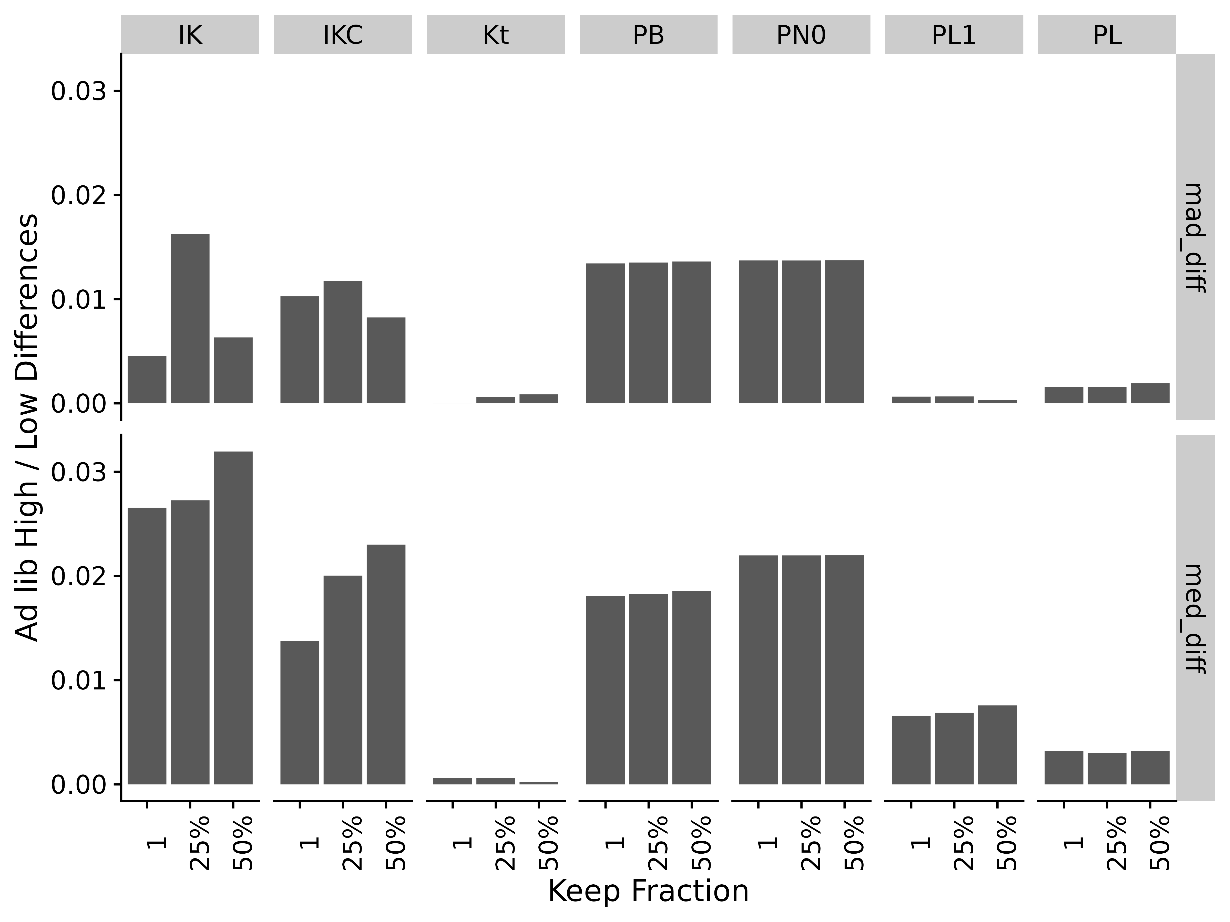

Figure S31. Difference of Ad lib feeding in high and low stamina medians and MADs by correlation method and applying different fractional cutoffs for rat stamina metabolomics data. Abbreviations for different measures and data are: IK: ICI-Kt; IKC: ICI-Kt * Completeness; Kt: Kendall-tau; PB: Pearson Base (raw values); PL: Pearson Log(x); PL1: Pearson Log(x + 1); PN0: Pearson No Zeros.

## References